West London Waste Plan
DRAFT Proposed Submission Version

11th November 2011

Produced for

London Borough of Hillingdon

Prepared by

Mouchel

Export House

Cawsey Way

Woking

GU21 6QX

UK

T 01483 731 368

F 01483 731 005

Document Control Sheet
Project Title | West London Waste Plan
Report Title | DRAFT Proposed Submission Version
Revision | 2.0
Status | Draft
Control Date | 11th November 2011

Record of Issue

Issue | Status | Author | Date | Check | Date | Authorised | Date
1.0 | Draft | M. Dale | 07/10/11 | B. Rounsefell | 12/10/11 | R. Prescott | 14/10/11
2.0 | Draft | M. Dale | 09/11/11 | B. Rounsefell | 10/11/11 | R. Prescott | 11/11/11

Distribution

Organisation | Contact | Copies
London Borough of Hillingdon | Shaun Jarmai | electronic
London Borough of Hillingdon | Brian Whitely | electronic

This report is presented to the London Borough of Hillingdon in respect of the West London Waste Plan and may not be used or relied on by any other person or by the client in relation to any other matters not covered specifically by the scope of this document.
Notwithstanding anything to the contrary contained in the report, Mouchel Limited is obliged to exercise reasonable skill, care and diligence in the performance of the services required by the client and shall not be liable except to the extent that it has failed to exercise reasonable skill, care and diligence, and this report shall be read and construed accordingly.
This assessment has been prepared by Mouchel Limited. No individual is personally liable in connection with the preparation of this document. By receiving this report and acting on it, the client or any other person accepts that no individual is personally liable whether in contract, tort, for breach of statutory duty or otherwise.

Executive Summary
- For some time, both the European and UK Governments have been concerned that we are sending too much of our waste for incineration or to landfill – not enough is being recycled and re-used.
- Consequently, the Government now requires every local authority to produce a plan which details how it will deal with waste generated in its area over the next 15 years. These plans make up a part of the authority’s Local Development Framework and show which factors they will take into account when deciding on whether to grant planning permissions for new waste facilities.
- In London, the Mayor has set out in the London Plan (2011) projections of how much municipal waste and commercial and industrial waste is likely to be generated in the capital over the next 20 years. Each borough is then allocated an apportionment of that waste that it is required to actively plan for managing and has to ensure that sufficient sites are identified to meet the apportionment targets. By meeting the apportionment London will dramatically improve its reliance on landfill and move towards being self-sufficient.
- In west London, six London boroughs have agreed to co-operate to produce a single waste plan for their combined area. When finalised, this plan will form part of each of their respective Local Development Frameworks. The West London Waste Plan details the amount for the different types of waste expected to be produced in west London up to 2026; identifies the current sites available to help deal with that waste; identifies the current shortfall of facilities needed, and proposes a set of further sites which might be used for waste facilities in the future.
- The West London Waste Plan has been prepared with the objective of ensuring compliance with the waste apportioned to the six boroughs as detailed in the London Plan (2011).
- The report comprises six sections, covering:
- An introduction to the West London Waste Plan;
- The Vision and Objectives of the Plan;
- An explanation of what will be needed in the future to manage waste;
- Details of the Proposed Sites for future waste management use;
- Policies to guide the determination of planning applications for new waste facilities, and
- A short explanation of how the Plan will be monitored in future.
- The existing sites and proposed sites are:
Table i: The proposed sites allocated for redevelopment
Site Number | Site Area (ha) | Borough | Description | Site Type
352 | 1.46 | Brent | Twyford Waste Transfer Station | Existing
1261 | 2.71 | Brent | Veolia Transfer Station, Marsh Road | Existing
309 | 1.15 | Ealing | Greenford Reuse & Recycling Site, | Existing
310 | 0.94 | Ealing | Greenford Depot, Greenford Road, | Existing
328 | 2.10 | Ealing | Quattro, Victoria Road, Park Royal | Existing
303 | 4.25 | Hillingdon | Victoria Road Transfer Station | Existing
353 | 3.11 | Hounslow | Transport Avenue Waste Transfer Station | Existing
342 | 3.67 | Richmond | Twickenham Depot | Existing
222 | 2.83 | Harrow | Council depot, Forward Drive | Proposed
244 | 3.12 | Hillingdon | Yeading Brook, Bulls Bridge | Proposed
2861 | 3.20 | Hounslow | Western International Market | Proposed

Contents
Document Control Sheet i
Executive Summary iii
Contents v
Figures & Tables vii
1 The West London Waste Plan 1
1.1 Preparation of the Plan 1
1.2 Why Is The West London Waste Plan Needed? 1
1.3 Relationship with Other Planning Strategies and the Plan’s Status 2
1.4 Sustainability Appraisal 5
1.5 Community and Stakeholder Consultation 6
1.6 Commenting on the Plan 6
1.7 Planning applications for waste management facilities 8
1.8 West London Waste Authority 9
1.9 Cross boundary movement of waste 9
1.10 Waste Minimisation 10
2 Vision and Objectives of the Plan 12
2.1 Vision 12
2.2 Strategic Objectives 12
3 Existing waste management and future waste management needs 13
3.1 Existing waste management 13
3.2 Municipal solid waste 13
3.3 Commercial and Industrial Waste 14
3.4 Construction, Demolition and Excavation Waste 15
3.5 Hazardous Wastes 16
3.6 Wastewater and Sewage sludge 16
3.7 Healthcare Waste 17
3.8 Agricultural Waste 17
3.9 Radioactive Waste 17
3.10 Role of Landfill in the Disposal of Waste 17
4 Future waste management 19
4.1 How much waste will need to be managed in west London? 19
4.2 How much land is needed? 19
4.3 What kind of facilities will be needed? 21
4.4 Construction, demolition and excavation wastes 21
4.5 Hazardous wastes 22
5 The Proposed Sites 23
6 West London Waste Plan Policies 25
6.1 Policy WLWP 1 – Safeguarding and protection of Existing sites 25
6.2 Policy WLWP 2 – Location of Waste Development 25
6.3 Policy WLWP 3 – Ensuring High Quality Development 27
6.4 Policy WLWP 4 – Decentralised Energy 29
6.5 Policy WLWP 5 – Sustainable Site Waste Management 29
7 Monitoring of the West London Waste Plan 31
8 Glossary 34
9 Appendices 43
Appendix 1 - Sustainability Appraisal 44
Appendix 2: General Waste Treatment Facility Description 48
Appendix 3: Borough waste arisings and apportionments 49
Appendix 4: Details of Existing Waste Management Sites considered to have potential for re-development as waste management facilities 50
Appendix 5: Details of Proposed New Sites with opportunity for developing waste management facilities 55

Figures & Tables
Figure 1-1: West London boroughs 1
Figure 1-2: The Waste Hierarchy 10
Figure 3-1 - West London Waste Authority MSW management (2009/10) 14
Figure 3-2 - C&I waste generation in west London by sector 15
Figure 3-3 - Fate of hazardous waste arisings from west London (2009) 16
Figure 3-4 - Destinations where west London sends residual waste for landfill disposal (2009) 18

Table 1-1: Self-Sufficiency targets for London 2
Table 1-2: Timetable for the development of the West London Waste Plan 2
Table 3-1: WLWA management of MSW (2006-2010) 13
Table 4-1: Quantity of waste forecast to be produced in west London and the apportionment figures from the London Plan (2011) for target years 19
Table 4-2: West London Capacity Requirements for Target Years based on the 2011 London Plan 20
Table 5-1: Existing waste sites considered to have potential for redevelopment 23
Table 7-1 - Monitoring programme for the West London Waste Plan 32

The West London Waste Plan

Preparation of the Plan
    - The West London Waste Plan is being prepared jointly by the six west London boroughs of Brent, Ealing, Harrow, Hillingdon, Hounslow and Richmond upon Thames. The area covered by the plan, and how it is split into its constituent boroughs is shown in Figure 1-1.
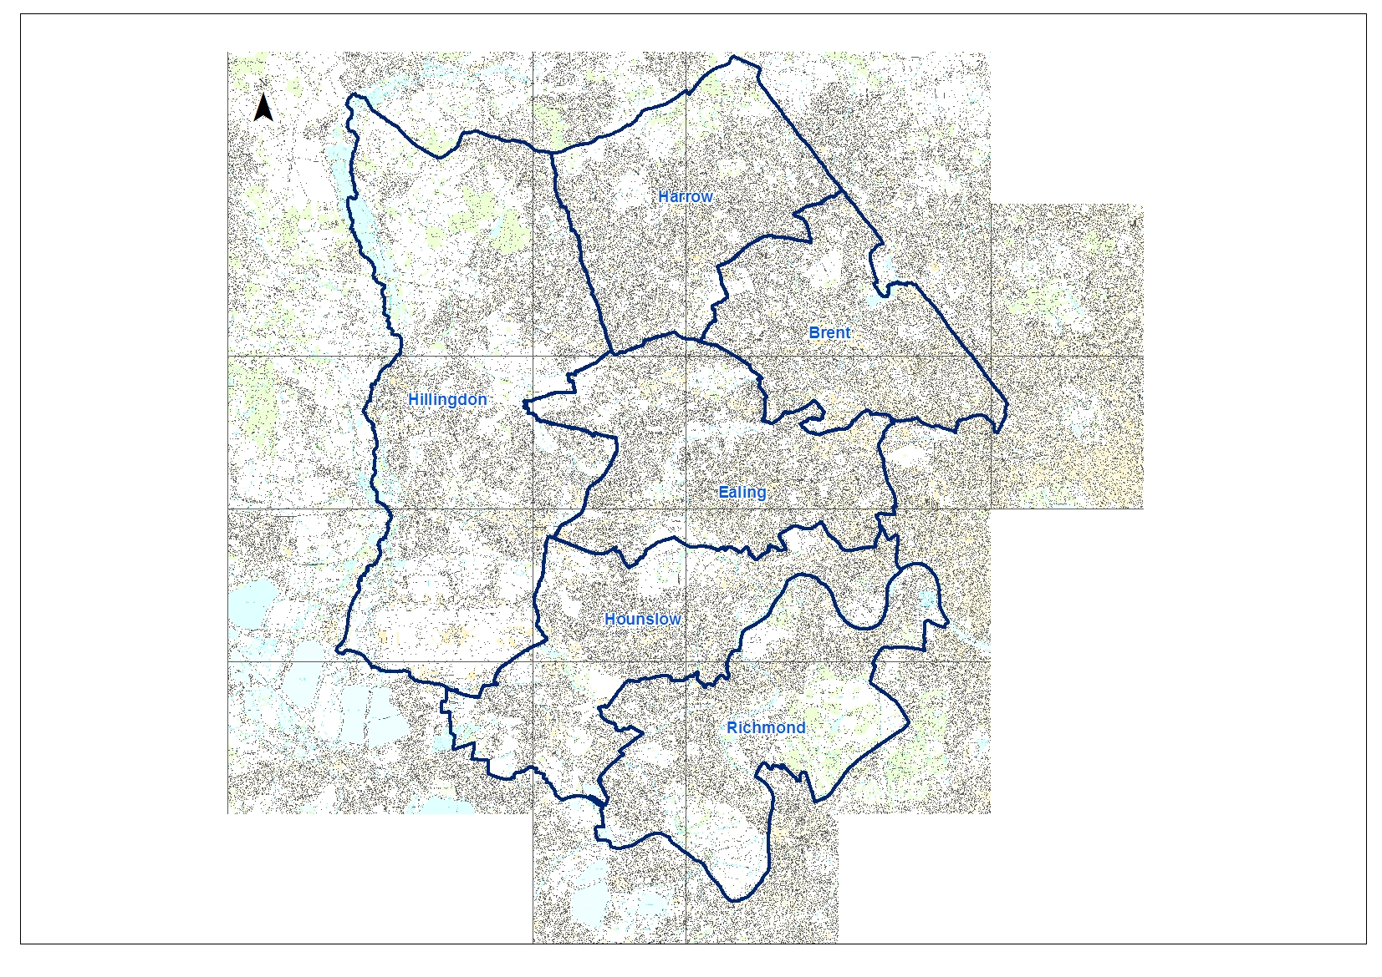 | 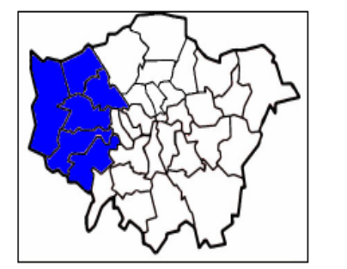
Figure 1-1: West London boroughs

Why Is The West London Waste Plan Needed?
    - The West London Waste Plan (the Plan) will provide a planning framework for the management of all waste produced in the six boroughs over the next 15 years. It is needed to comply with the Mayor’s London Plan (2011), which sets out targets for recycling and composting for waste from households, businesses and industry. The London Plan (2011) also requires that the majority of waste generated in London is managed in London, so that the Capital moves towards waste self-sufficiency by 2031.
    - Currently, a significant amount of waste is transferred outside of London for treatment or disposal in landfill. Table 1-1 shows the London Plan (2011) targets for the proportion of waste to be managed within London for various target years. Overall, the target states that the aim is to manage the equivalent of 100 per cent of London’s waste within London by 2031.
Table 1-1: Self-Sufficiency targets for London
Waste stream | 2015 | 2020 | 2031
Municipal Solid Waste | 45% | 50% | 60%
Commercial & Industrial Waste |  | 70%
Construction, Demolition & Excavation |  | 95%
All wastes |  |  | 100%

    - Under the Planning and Compulsory Purchase Act 2004, London boroughs are required to replace their existing Land Use Plans (called Unitary Development Plans) with Local Development Frameworks. Local Development Frameworks comprise a number of planning documents and must contain both specific policies for waste and sites identified for waste use. These planning documents must be in general conformity with the London Plan; the Mayor of London’s planning strategy for the capital, in addition to national planning policy. Before the Plan can be adopted it will be independently tested through a public examination to ensure it meets all of the key tests for a sound plan.
    - The Plan will outline the proposed sites for waste management development in the plan area and provide a set of policies with which waste developments must conform. The Plan will cover the London Plan (2011) apportionment targets outlining the amount of waste from households, business and industry required to be managed in the west London area up to 2026. The timetable for the production of the Plan and for its final adoption is shown in Table 1-2.
Table 1-2: Timetable for the development of the West London Waste Plan
Period | Stage of development
January - March 2009 | Issues and Options Consultation
February - March 2011 | Draft Plan Consultation
January - February 2012 | Representations on Proposed Submission Version
January 2013 | Examination of the Plan
May 2013 | Adoption of the Plan by the west London boroughs

Relationship with Other Planning Strategies and the Plan’s Status
    - The Plan is influenced by, and has to give consideration to, relevant national, regional and local policy in relation to waste development (both adopted and emerging).
    - This Plan will be adopted, after Examination in Public and consideration of the appointed Inspector’s report, by each of the constituent boroughs. It will take on the status of a statutory Development Plan Document, and its policies will be accorded considerable weight by each local planning authority and the Secretary of State in determining planning applications for waste management facilities within the plan area.
European Legislation
    - The Waste Framework Directive [2008/98/EC, which has been implemented by the Waste England and Wales Regulation 2011,] is the principal EU legislation for waste, and requires that measures be put in place to ensure that waste is recovered or disposed of without endangering human health or causing harm to the environment. A key principle of the directive is the waste hierarchy, with the objective to manage waste as near to the top of the hierarchy as possible.
National Policy
    - National policy relevant to waste development is outlined in the UK Sustainable Development Strategy which sets out the national policy approach to ensuring sustainable development. The Waste Strategy for England 2007 was published following a comprehensive review of Waste Strategy 2000. The key objectives of these documents are to:
- Decouple waste growth from economic growth and put more emphasis on waste prevention and re-use;
- Increase diversion of municipal and non-municipal waste from landfill;
- Secure investment in waste infrastructure; and
- Get the most environmental benefit from the investment through increased recycling of resources and recovery of energy from residual waste.

The Waste Strategy for England (2007) also sets national targets for recycling and composting of household waste and the recovery of municipal waste.
    - Planning Policy Statement 10: Planning for Waste Development outlines the key objectives and considerations when producing planning policies for waste development and the consideration of relevant applications for development.
Regional Policy
    - The London Plan (2011) provides the regional planning framework for the six west London boroughs jointly preparing the Plan and outlines the principal guidelines for waste development. The Government has agreed that, although regional strategies for other parts of England will be abolished, the London Plan will continue to provide strategic guidance within the capital and thus be accorded significant weight in guiding the evolution of development plans and in determining planning applications.
    - Boroughs must be in general conformity with the relevant waste management policies in the London Plan (2011). This includes an apportionment of the tonnages of municipal and commercial and industrial waste to be managed by each London borough; revised targets for recycling of municipal waste; and new targets for recycling of commercial and industrial waste and recycling or reuse of construction and demolition waste.
    - Each of the six west London boroughs is preparing a number of other strategies and plans which, along with the Plan, will form its Local Development Framework (LDF).
    - Each borough must produce Development Plan Documents (DPDs) which make up their LDF. The main DPD is the Core Strategy which sets out the general spatial vision and objectives for delivery of the LDF. It also helps the borough to deliver its Community Strategy and must reflect the regional strategy, which is set out in the London Plan.
    - The Plan is a DPD (see 1.3.2) and, although being prepared jointly by the six west London boroughs, must be aligned with their individual Core Strategies and adopted development plans.

Sustainability Appraisal
    - The Plan has been subjected to a Sustainability Appraisal (SA) during the course of its development. An SA ensures that planning documents accord with the principles defined in the Government’s UK Sustainable Development agenda. The timing of the SA aims to ensure that sustainability considerations are taken into account early in the process of policy development. A Habitats Regulations Assessment (HRA); an Equalities Impact Assessment (EqIA;) and a Strategic Flood Risk Assessment (SFRA) have also been undertaken in conjunction with the development of this Plan. Appendix 1 provides details on the process for each of these assessments.

Community and Stakeholder Consultation
    - The West London Waste Plan has been informed by consultation with statutory bodies, local organisations, key stakeholders and the wider community throughout its preparation. This has been carried out in accordance with each borough’s “Statement of Community Involvement”.
    - Initial consultation took place in January and February 2009 on the key issues which the West London Waste Plan needs to address, as set out in the West London Waste Plan Issues and Options report. A wide range of responses was received via the various public workshops and meetings held across the six boroughs, via the project website and in writing. The boroughs’ preferred approach to deal with the issues raised, as well as a list of the proposed sites, was published for comment in February 2011 in the Proposed Sites and Policies report. Staffed drop-in sessions in each of the six boroughs were attended by over 120 people along with 64 people attending further meetings. In addition to responses received at these events, 248 questionnaires were completed, and a further 133 additional written and email submissions were made alongside two petitions containing 2,399 signatures. A full report on this consultation is available on the West London Waste Plan website (www.wlwp.net).

Commenting on the Plan
    - You can make representations on this proposed submission draft of the West London Waste Plan, including the Sustainability Appraisal and Equalities Impact Assessment during a six week period commencing from the 19 January 2012.
    - All representations made will be considered by a Planning Inspector at a formal process called an examination in public. The purpose of the examination is to consider whether the Waste Plan complies with the legal requirements and is ‘sound’.
    - Since the Planning Inspector’s role is to answer these questions, any comments on the Plan will need to be related to legal compliance and “soundness”.
    - In summary, comments on the “soundness” of the Plan need to address the following issues:
    - Is it ‘justified’? This means that the document must be:
      - founded on a robust and credible evidence base
      - the most appropriate strategy when considered against the reasonable alternatives
    - Is it ‘effective’? This means that the document must be:
      - deliverable
      - Flexible, so that the local authorities can adapt the plan to respond to unexpected changes in circumstances
      - able to be monitored against clear, and measurable criteria
- Is it consistent with national policy?
    - More guidance on the meaning of these terms will be included with the comments form. Other guidance is available from the Planning Inspectorate and in Planning Policy Statement 12 which outlines the requirements for Core Strategies .
    - All responses must be received by 1 March 2012. All representations and other material in support of any comments made should be sent to:
CAG Consultants
West London Waste Plan Consultation
Gordon House, 6 Lissenden Gardens, London, NW5 1LX
Email: consultation@wlwp.net
    - Comments can also be given via the website:
www.wlwp.net
    - The West London Waste Plan Proposed Submission document and an accompanying Technical Report, Sustainability Appraisal and Equalities Impact Assessment are available for download via the West London Waste Plan website at: www.wlwp.net. Hard copies are also available to view at:
- All Libraries across the six boroughs; and
- Local Council Offices across the six boroughs.
    - The west London authorities will seek to ensure that all reports are accessible to everyone and will offer assistance to those who are blind or partially sighted or do not speak English fluently. This may include spoken or written translation in different languages, Braille, audio or large print format.
    - The representations made on the West London Waste Plan will be forwarded to the Planning Inspector.
    - There will be an independent Examination in Public of the West London Waste Plan which will start upon its submission to the Secretary of State in September 2012 and culminate in a hearing before an independent Planning Inspector in January 2013. Following the Examination, the Inspector will issue a binding report. Following ratification of the Inspector’s report by each borough, the West London Waste Plan will be formally adopted by each borough in May 2013.

Planning applications for waste management facilities
    - The Plan and its policies will be the primary material consideration when assessing planning applications for new waste management facilities in the west London boroughs. After this Plan has been adopted, developers should first use the West London Waste Plan to identify a suitable site when considering the development of a potential new waste management facility. If the developer cannot find a suitable site in the Plan, any alternative site proposed will have to conform to the policies within the Plan. Developers should also consider requirements and policies within the following documents before submitting a planning application for a waste management facility in west London:
- Any national statutory guidance, e.g. Planning Policy Statement 10;
- Borough Development Plan Documents;
- London Plan;
- Mayor of London Order (2008); and
- Supplementary Planning Guidance from the Mayor or Supplementary Planning Documents from the relevant borough.

West London Waste Authority
    - The West London Waste Authority (WLWA) is the statutory Waste Disposal Authority for the six west London boroughs and as such is solely responsible for the transport, treatment and disposal of municipal waste collected by the boroughs.
    - The WLWA and its constituent boroughs consulted on and subsequently adopted a Joint Municipal Waste Management Strategy in 2005. It sets out the future waste and recycling plans and targets for the Authority and each of the six boroughs. An Addendum followed in 2009, providing an update on the Authority’s Partnership waste management performance.
    - The WLWA has a vision of achieving a 70% reuse/recycling/recovery rate and zero waste to landfill although there is no timescale for these targets.
    - In 2008/09 the WLWA and its constituent boroughs dealt with a total of 767,000 tonnes of municipal waste, including abandoned vehicles. Of this total some 176,000 tonnes was recycled, 84,000 tonnes was composted, and the remaining 507,000 tonnes was sent for disposal, nearly all by rail from the WLWA’s transfer stations in Brentford and South Ruislip, to landfill sites in Oxfordshire and Buckinghamshire.
    - From 2009/10 increasing quantities of waste not recycled or composted will be diverted from landfill. The WLWA has a contract to send waste to the Lakeside Energy from Waste plant near Slough, for the next 25 years. This contract started in 2009/10 with an annual tonnage of 25,000 tonnes. It remains at this level until 2014/15 when for one year the tonnage increases to 45,000 tonnes. The following year (2015/16) the tonnage increases to 90,000 tonnes and remains at that level until the final year of the contract in 2034/35.

Cross boundary movement of waste
    - Whilst waste is both generated and treated within west London boroughs, there is still the transfer of waste both into the WLWA area as well as exported out of it for treatment in other areas. It is important to assess the level of this cross boundary movement of waste and to identify potential implications this may cause to the West London Waste Plan during the Plan period.
    - The WLWA and its constituent boroughs exported 995,900 tonnes of waste out of west London for landfill disposal in 2008. The majority of this waste was sent to Buckinghamshire (28%) and Bedfordshire (24%), followed by Oxfordshire (12%), with the remaining 36% divided between eight other authorities.
    - The relevant authorities to whom this waste was exported have adopted waste plans which have identified sufficient sites to accommodate the declining levels of waste that will be exported from London for the period of this Plan, which is until 2026.
    - As such, it is considered with the implementation of the policies in this Plan which are designed to help achieve the London Plan (2011) aim of 100% of waste produced in London being managed in London by 2031, and the move towards providing energy production from waste sites, that there will be no overriding issues with regards to the impact of any cross boundary movement of waste.

Waste Minimisation
    - The west London boroughs are committed to waste reduction and minimisation initiatives and understand the importance of such issues to the residents of west London and to the success of sustainable waste management in the area. Although the Plan cannot directly enforce waste reduction, it will encourage waste minimisation through appropriate policies.
    - The West London Waste Plan supports the management of waste according to the waste hierarchy (Figure 1-2) as identified in the Waste Strategy for England and the London Plan (2011).

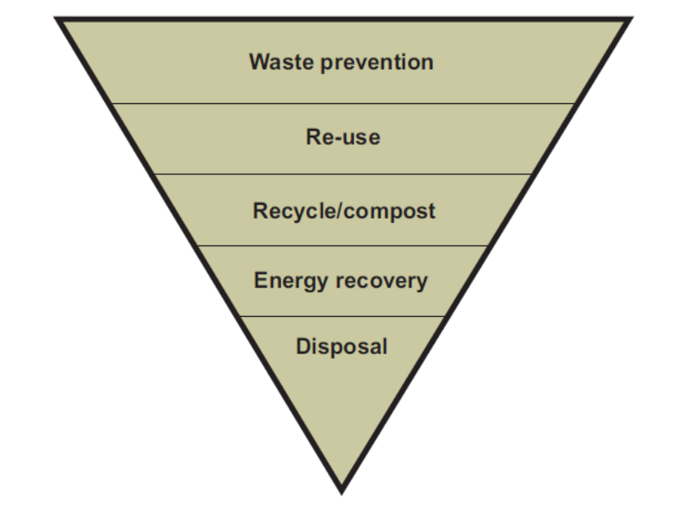
Figure 1-2: The Waste Hierarchy

Each of the six boroughs is already dealing with wider waste issues such as encouraging waste minimisation and increasing recycling in accordance with the waste hierarchy. The waste hierarchy states that we should first try to reduce and re-use waste, then recycle waste into useful materials and, if this is not possible, recover energy from waste before considering the safe disposal of waste as a last resort. All boroughs operate household waste recycling collections, reuse and recycling centres and offer information on waste minimisation activities such as home composting or using re-usable nappies.

Vision and Objectives of the Plan

Vision
    - The unique characteristics of west London, as well as the key challenges and opportunities that have been identified in developing the Plan, have fed into the vision of the Plan, which is supported by its aims and objectives.
    - The vision of the Plan ensures that the long-term management of waste in west London will allow for the best possible outcomes for the west London boroughs. It brings together national, regional and local guidance along with the views of key stakeholders and the evidence base that underlies the Plan.
West London Waste Plan Vision
By 2026, the West London Waste Plan area will have made provision for enough waste management facilities in the right locations to provide for the sustainable management of waste. It will seek to do so whilst protecting the environment, stimulating the economy and balancing the needs of west London’s communities.

Strategic Objectives
    - The West London Waste Plan strategic objectives were developed in response to the key issues for west London and responses received through community consultation.
West London Waste Plan Strategic Objectives
- To identify sufficient land for the management of the six boroughs’ pooled waste apportionment as set out in the London Plan, including safeguarding existing waste sites and maximising their use as waste management sites.
- To ensure that waste is managed as far up the waste hierarchy as possible, by encouraging the minimisation of waste and the use of waste as a resource.
- To reduce the impact of waste management on climate change by encouraging the use of sustainable transport and new, clean technologies, whilst seeking to locate waste management facilities as close to waste sources as practicable.
- To ensure that, through appropriate policies, waste facilities meet the highest standards possible of design, construction and operation to minimise adverse effects on local communities and the environment.
- To support the key aims and objectives of Brent, Ealing, Harrow, Hillingdon, Hounslow and Richmond’s Sustainable Community Strategies.

Existing waste management and future waste management needs

Existing waste management
    - West London produces, and is expected to continue to produce, a significant quantity of waste. This section looks at the different types of waste being generated in west London and how it is currently being managed, along with future trends allowing for the west London boroughs to determine what infrastructure is required to meet the London Plan (2011) waste apportionment figures.

Municipal solid waste
    - Municipal Solid Waste (MSW) in the west London boroughs is managed by the WLWA and includes household waste, kerbside collected recyclables, green waste and waste and recyclables collected at household waste and recycling centres.
    - Overall in 2009/10 the WLWA and its constituent boroughs managed approximately 693,000 tonnes of MSW. Of this total, 41% was reused, recycled or composted, with the remaining 59% sent for disposal, nearly all to landfill outside west London. This figure for landfill compares favourably with previous years (Table 3-3), both in terms of the total tonnage sent to landfill and the percentage of the total MSW stream this represents. Figure 3 shows the means of waste management in the plan area in 2009/10, the latest full year for which figures are available.
Table 3-3: WLWA management of MSW (2006-2010)
Waste (tonnes) | 2006/07 | % | 2007/08 | % | 2008/09 | % | 2009/10 | %
Recycling & Reuse | 116,000 | 14.6 | 131,000 | 16.9 | 139,000 | 19.0 | 155,000 | 22.4
Composting | 62,000 | 7.8 | 71,000 | 9.2 | 84,000 | 11.5 | 86,000 | 12.4
Energy Recovery | 3,000 | 0.4 | 3,000 | 0.4 | 1,000 | 0.1 | 12,000 | 1.7
Landfill | 603,000 | 75.8 | 555,000 | 71.8 | 485,000 | 66.2 | 395,000 | 57.0
Materials Recovery Facility | 13,000 | 1.6 | 13,000 | 1.7 | 25,000 | 3.4 | 45,000 | 6.5
Total waste | 796,000 |  | 773,000 |  | 733,000 |  | 693,000

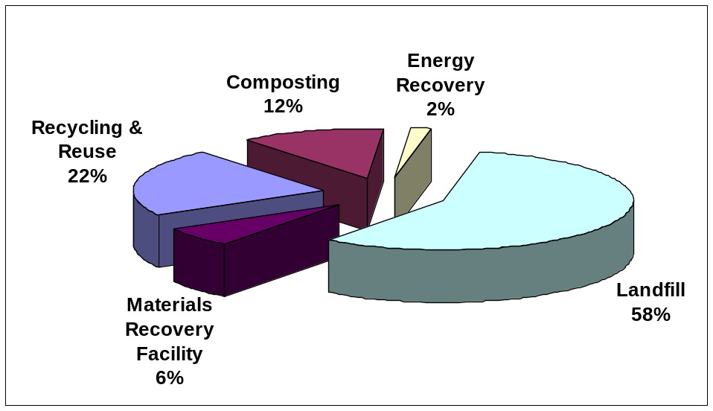
Figure 3-3 - West London Waste Authority MSW management (2009/10)

    - As the statutory body responsible for managing MSW generated in the west London boroughs, the WLWA is in the process of procuring a new long term contract for the management of this waste. The main objective of the procurement is to eliminate (or significantly reduce) the landfilling of municipal waste. The WLWA has been working in partnership with its constituent boroughs and has produced a Procurement Strategy. The procurement is outcome-based, with targets for landfill diversion, affordability, recycling and carbon impact and has no preference on the technology to be used.
    - The WLWA, following consultation with the GLA, issued an Official Journal of the European Union (OJEU) notice on 16th May 2011 to commence the procurement process of the treatment of up to 300,000 tonnes of municipal waste per year.

Commercial and Industrial Waste
    - Historically, Commercial and Industrial Waste (C&I waste) was categorised as a distinct type of waste in the UK. However with the implementation of the European Waste Catalogue (EWC) as a method of coding waste, much of this waste is increasingly being categorised as ‘Municipal Wastes’.
    - The DEFRA Survey of C&I waste arisings for 2009 estimated west London produced 845,000 tonnes of C&I waste during that year, which is a reduction of 621,000 tonnes (42%) from the previous C&I Survey in 2002/03, which estimated that 1,466,000 tonnes of C&I waste was produced. Conversely, the London Plan 2011 has estimated that west London produced 1,299,000 tonnes. For purposes of consistency, this Technical Report will use the more conservative London Plan (2011) C&I waste data estimate, as this was used as part of the basis for the apportionment figures determined for west London boroughs and offers flexibility over the DEFRA 2009 estimate.
    - Figure 3-4 displays the generation of C&I waste by sector in west London, with the largest source of waste arising in the retail and wholesale sector (approximately one third). The largest components of the C&I waste stream in west London are mixed waste (41%) followed by non-metallic waste (30%) and the remainder including mostly chemical or animal and vegetable wastes.
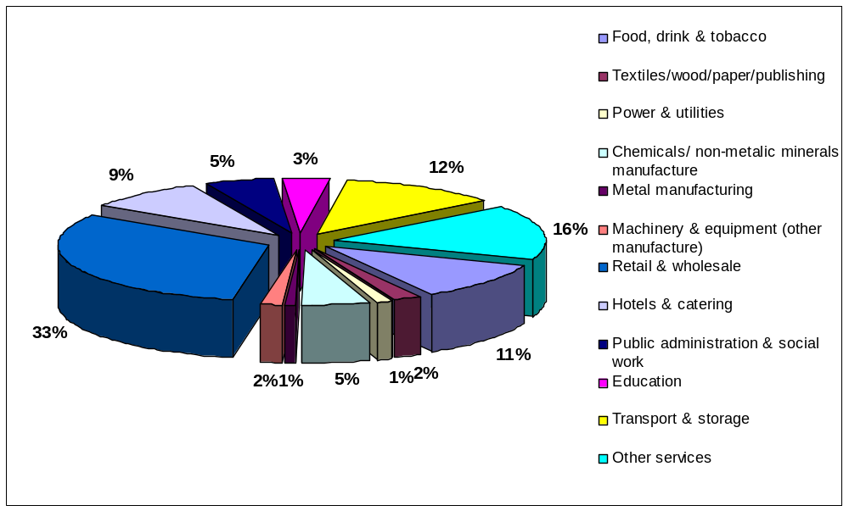
Figure 3-4 - C&I waste generation in west London by sector

Construction, Demolition and Excavation Waste
    - Construction, Demolition and Excavation waste (CD&E) waste makes up almost half of London’s total waste, and this is also reflected in west London, where 47% of the total waste arising in the boroughs is CD&E waste.

Analysis of the most recent Environment Agency data (2009) for CD&E waste indicates that an estimated 754,000 tonnes was generated in west London, while 837,000 tonnes was transported into the area, resulting in a net importation of about 83,000 tonnes of CD&E waste. The principal fate of CD&E waste exported from west London is reprocessing (66%), with a further 30% landfilled, and the remaining amount either treated or with an unknown fate. In comparison, 99% of CD&E waste imported into west London is transferred for treatment or disposal elsewhere, with the remainder managed through recycling, treatment or landfill within the area.

Hazardous Wastes
    - Hazardous wastes are categorised as those that are harmful to human health, or the environment, either immediately or over an extended period of time. They range from asbestos, chemicals, and oil through to electrical goods and fluorescent tubes. In 2009, west London exported approximately 73,000 tonnes. Compared with other waste streams generated in west London, hazardous waste is not a large waste stream, but is a sensitive one which requires a range of specialist facilities for treatment and disposal.
    - In 2009, west London boroughs exported hazardous waste to 48 different destinations across England, with the main destinations including Northamptonshire, the Western Riverside Waste Authority, Berkshire; and Surrey. The fate of this hazardous waste generated in west London is presented in Figure 3-5.
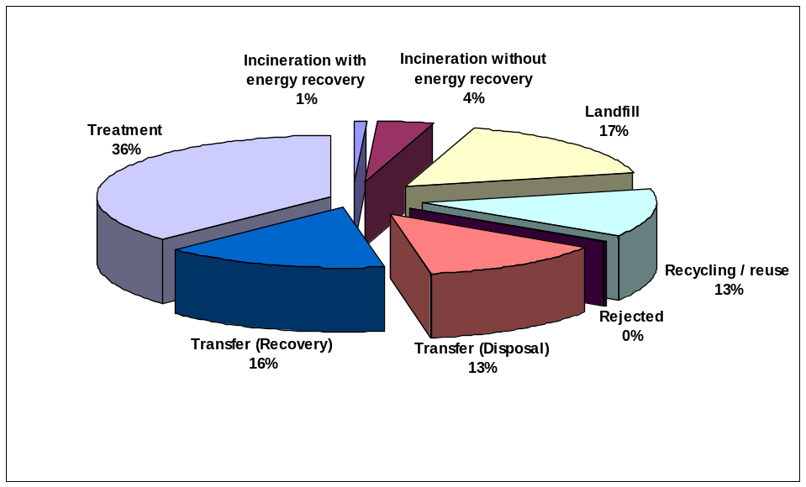
Figure 3-5 - Fate of hazardous waste arisings from west London (2009)

Wastewater and Sewage sludge
    - Thames Water Limited is responsible for wastewater and sewage sludge treatment in London and, as part of this responsibility, it manages key pieces of sewerage infrastructure, including a number of sewage treatment works (STW). The majority of wastewater in west London is either drained to Mogden STW in Isleworth, Beckton STW in East London, or Hogsmill STW in Kingston upon Thames. During 2010, these facilities generated over 100,000 tonnes of sewage sludge (dry solids) with all of this sludge being beneficially reused through either incineration with energy recovery, recycled to agricultural land or used for land restoration.

Healthcare Waste
    - Healthcare waste covers a wide range of hazardous and non-hazardous waste including from hospitals, nursing homes, health centres, GP, dental or veterinary surgeries etc. West London’s healthcare waste is either managed by the boroughs (Ealing, Hounslow and Richmond upon Thames) or their Primary Care Trusts (PCT) where the collection, transfer and disposal is taken care of by local waste contractors (Harrow). Brent and Hillingdon have a combination of the two, in which they only undertake the management of household collections with contractors managing the remainder. Healthcare waste accounts for approximately 822 tonnes per year of waste arising in west London. However, Hillingdon hospital also has an incinerator used for clinical waste disposal and it is estimated that this facility received approximately 7,600 tonnes of clinical waste for disposal in 2009.

Agricultural Waste
    - The total amount of agricultural waste arisings in west London in 2009 was approximately 6,900 tonnes. The majority of this waste (94%) was sent to a Civil Amenity site located in Harrow, with a further 5% composted in Hillingdon and the remaining 41 tonnes sent to a clinical transfer facility in Brent.

Radioactive Waste
    - Limited information is available regarding the generation of radioactive waste in west London, with no records held by either the Environment Agency of the Department of Energy and Climate Change. It is assumed that, as west London does not accommodate any nuclear power generation facilities, radioactive waste arisings in the area are low. The only identified sources that may generate small amounts of low level radioactive waste (LLW) and very low level radioactive Waste (VLLW) are hospitals and universities in the boroughs. Most radioactive waste produced by minor waste producers is not reported in the UK Inventory as it is either low volumes of LLW that can be disposed of by “controlled burial” at landfill sites, or low volume VLLW that can be disposed of with MSW and C&I wastes at landfill site.

Role of Landfill in the Disposal of Waste
    - Landfill disposal accounted for approximately 1,056,000 tonnes of west London’s waste in 2009, with over 94% of that exported to landfill facilities outside of west London. The remaining 60,080 tonnes was sent to Harmondsworth Landfill located in southwest Hillingdon. Figure 3-6 illustrates the majority of this was sent to both Buckinghamshire (28%) and Bedfordshire (24%), followed by Oxfordshire (12%) and the remaining 36% was divided between eight other authorities.

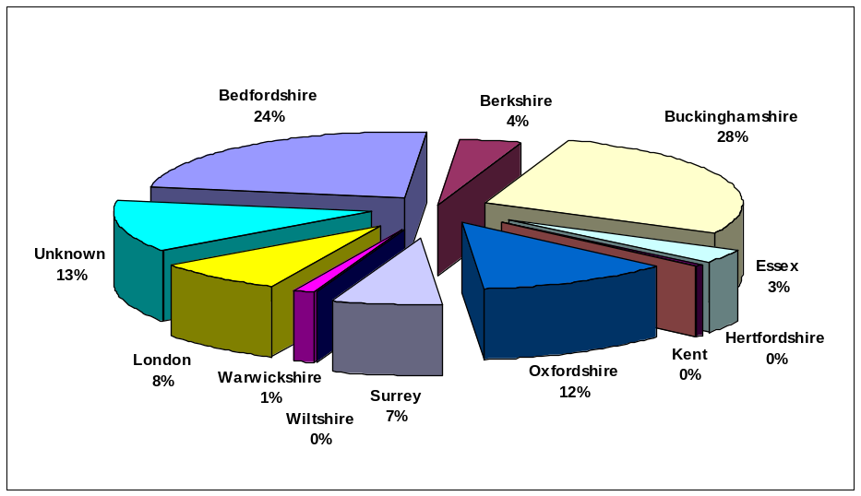
Figure 3-6 - Destinations where west London sends residual waste for landfill disposal (2009)
    - There are several different types of landfill, all of which play a different role in helping to manage west London’s waste. Generally these are categorised by the types of waste they can accept for disposal.
    - Non-hazardous landfill usually accounts for residual MSW and C&I waste, whereas Inert Landfill usually accounts for CD&E waste. Hazardous waste landfills are highly specialised and only accept certain hazardous waste, while stable, non-reactive hazardous waste (SNRHW) landfill can be a placed in a cell (specifically designed in a landfill to accept SNRHW (e.g. asbestos)) isolated from biodegradable waste.
In order to ensure that for the life of the WLWP there continues to remain capacity in areas surrounding London for the landfill of residual waste, further information was sourced. Published waste planning documents for the counties and regions concerned were consulted and followed up with discussions with local waste officers to cross-reference and confirm the information where possible.
Regional Spatial Strategies for London, the South East and East of England all refer to the requirement for the on-going (but declining) landfilling of residual waste from London in surrounding areas and provide directions on the apportionment for each of the waste planning authorities in their region. Subsequently, the counties that currently landfill residual waste from west London in significant quantities (as per Figure 3-6) will continue to be able provide capacity to receive waste for disposal at landfill from west London during the life of the WLWP, albeit in declining amounts.

Future waste management

How much waste will need to be managed in west London?
    - The London Plan (2011) sets a target for London to become the equivalent of 100% self-sufficient in the management of waste by 2031. To achieve this target each borough has been given a share of London’s total MSW and C&I waste to manage (called the borough’s “apportionment” figure) for which it must identify sufficient and suitable potential sites for the development of waste management facilities. The west London boroughs have pooled their apportionments and will meet the collective apportionment figures.
    - Waste arisings projections are also included in the London Plan (2011), with these figures considered the most up-to-date for west London and were also used by the Mayor to determine the apportionment figures. The waste arisings and apportionment figures for west London are displayed in Table 4-4.
Table 4-4: Quantity of waste forecast to be produced in west London and the apportionment figures from the London Plan (2011) for target years
 | 2011 | 2016 | 2021 | 2026
MSW arisings (tonnes per annum) | 798,000 | 826,000 | 852,000 | 879,000
C&I waste arisings (tonnes per annum) | 1,287,000 | 1,258,000 | 1,240,000 | 1,233,000
Total (MSW and C&I waste) arisings (tonnes per annum) | 2,085,000 | 2,084,000 | 2,092,000 | 2,112,000
London Plan (2011) Apportionment (tonnes per annum) | 1,399,000 | 1,595,000 | 1,798,000 | 2,019,000

How much land is needed?
    - The London Plan (2011) is the statutory regional strategy of London. In order to comply with central Government requirements and be considered a “sound” planning document, the West London Waste Plan is being prepared in accordance with the waste projections and apportionment figures contained in the London Plan (2011). The west London boroughs are not required to meet the individual MSW and C&I waste apportionment figures in the London Plan (2011) as long as the total apportionment figure is addressed.
    - Currently, west London has few waste management sites but it has many waste transfer sites which bulk waste for disposal elsewhere. The intention of the Plan is to maximise the use of the existing waste sites in the area, including re-orientation of some waste transfer sites to new waste management facilities, as well as the identification of new sites in west London for waste management uses.
    - The current existing waste management capacity in west London is 811,541 tonnes per annum including both waste treatment sites and the recycling undertaken at household waste and recycling centres and civic amenity sites. Subsequently, west London will need to develop extra waste management facilities during the period to 2026 to address ‘gap’ between the apportionment figures and the waste management capacity that currently exists.
    - For the six west London boroughs to meet the apportionment for MSW & C&I waste, an additional 2,100,645 treatment capacity will need to be planned and licensed by 2021 and circa 3,222,380 tonnes by 2026. In order to determine how much area will be required to provide this waste management capacity, an average processing capacity of 54,012 tonnes per annum per hectare was used based on the range of possible processes and their processing intensity.
    - The London Plan (2011) does not prescribe the specific waste management technologies, their scale, nor the number that will need to be implemented across London. Accordingly, the West London Waste Plan also does not take a prescriptive approach to what types of waste management facilities/technologies are required. This approach will allow for innovation in the management of waste to be incorporated into development in west London.
    - The identification of the land required to meet the apportionment is displayed in Table 4-5 and shows that by 2026, west London boroughs need to have an additional 22.4 hectares of waste management capacity.
Table 4-5: West London Capacity Requirements for Target Years based on the 2011 London Plan
 | 2011 | 2016 | 2021 | 2026
Apportionment (tonnes per annum) | 1,399,000 | 1,595,000 | 1,798,000 | 2,019,000
Total existing waste management capacity (tonnes per annum) | 811,541 | 811,541 | 811,541 | 811,541
Additional capacity required to meet the apportionment (tonnes per annum) | 587,459 | 783,459 | 986,459 | 1,207,459
Land to address the capacity gap (hectares) | 10.9 | 14.5 | 18.3 | 22.4

    - The West London Waste Plan has identified land area slightly above its requirements (using existing safeguarded and new sites) to give the Plan flexibility should some sites not come forward for development during the lifetime of the Plan. Annual monitoring of the plan will prevent overprovision of sites occurring.
    - The Plan identifies 22.4 hectares of land is required to develop waste management capacity by 2026.
    - In order to meet this land allocation, eight existing waste transfer sites (accounting for 19.4 hectares) have been identified as suitable and available for reorientation into waste treatment facilities. An additional 9.2 hectares was identified as potentially deliverable from new sites in west London. Overall, it is thus estimated that within west London there is 27.6 hectares of land potentially available for waste treatment, which exceeds the land allocation required to meet the London Plan (2011) and creates flexibility in the Plan.

What kind of facilities will be needed?
    - Ensuring that more waste is managed within west London will mean that a range of different waste management facilities will be considered including recycling, composting and energy recovery. Modern waste management facilities utilise clean technologies and are subject to stringent regulation and monitoring of their operations and impacts. Innovative design and architecture can also be applied making facilities sensitive to their settings, although many technologies can be housed in industrial building similar in appearance to a warehouse. Table 3-4 in Appendix 4 to this report gives a brief description of the principal waste management technologies.
    - It is important that modern methods of dealing with waste are found which also seek to produce valuable, usable products such as fuel, heat and power. Waste facilities should be seen positively, as an opportunity rather than a ‘bad neighbour’, as they can be co- located with developments and industry to provide heat, power and other beneficial products attractive to industrial, commercial and potentially residential developments.
    - The West London Waste Plan identifies sites for general waste use and to use the policies within the Plan to manage such developments to ensure they are suitable for the site and its surrounding land uses. The Plan is designed to be flexible to allow for developments and improvements in waste management technologies and the changing habits of consumers and waste producers. A planning application will have to be submitted for each proposed development, which will be assessed in line with the West London Waste Plan and other borough plans and strategies and through public consultation.

Construction, demolition and excavation wastes
    - Construction, Demolition and Excavation (CDE) waste is a large waste stream within London, although it is not included within the apportionment target assigned to boroughs. Accordingly, no allocations are made in this plan for facilities dealing specifically with such wastes. The preference in west London is to ensure more on-site recycling and re-use takes place in accordance with Policy 5.18 of the London Plan (2011) by using Policy WLWP 4 whilst ensuring that boroughs monitor the types and capacities of waste management facilities developed against any new waste arising data that is produced.

Hazardous wastes
    - Hazardous waste can cause concern amongst residents and communities; however it is also not included within the apportionment targets assigned to boroughs. Policy 5.19 of the London Plan (2011) states that the Mayor will prepare a Hazardous Waste Strategy for London and will work in partnership with the boroughs, the Environment Agency, industry and neighbouring authorities to identify the capacity gap for dealing with hazardous waste and to provide and maintain direction on the need for hazardous waste management capacity.
    - The West London Waste Plan therefore makes no specific provision for hazardous wastes. However, planning applications for hazardous waste facilities will be determined in the same way as applications for all waste management facilities and the capacity of hazardous waste facilities will be monitored closely to establish whether additional provision is required at a later date.

The Proposed Sites
    - The West London Waste Plan, in accordance with the criteria outlined in PPS10, has identified a number of existing and new sites which it considers will ensure adequate waste management provision for the lifetime of the Plan. The sites have been subject to a detailed evaluation and assessment which is documented in the accompanying Technical Report. Further details of these sites including details of their locations, are contained in Appendices 4 and 5 of this Plan.
    - The Plan identifies (see paragraph 4.2.9) that 27.6 hectares are considered available on existing and new waste sites. Maps showing the location and the site boundary of all sites are provided in Appendices 4 and 5 of the Plan. Table 5-1 sets out those existing sites capable of redevelopment, while Table 5-2 refers to potential new waste sites.
Table 5-6: Existing waste sites considered to have potential for redevelopment
Site Number | Site Area (ha) | Borough | Description | Site Type
352 | 1.46 | Brent | Twyford Waste Transfer Station | Transfer Station
1261 | 2.71 | Brent | Veolia Transfer Station, Marsh Road | Transfer Station
309 | 1.15 | Ealing | Greenford Reuse & Recycling Site, | Transfer Station
310 | 0.94 | Ealing | Greenford Depot, Greenford Road, | Depot Facility
328 | 2.10 | Ealing | Quattro, Victoria Road, Park Royal | Transfer Station
303 | 4.25 | Hillingdon | Victoria Road Transfer Station | Transfer Station
353 | 3.11 | Hounslow | Transport Avenue Waste Transfer Station | Transfer Station
342 | 3.67 | Richmond | Twickenham Depot | Depot Facility

Table 5-2: Proposed new sites with opportunity for developing waste management facilities
Site Number | Site Area (ha) | Borough | Description
222 | 1.83 | Harrow | Council depot, Forward Drive
244 | 3.12 | Hillingdon | Yeading Brook, Bulls Bridge
2861 | 3.20 | Hounslow | Western International Market

West London Waste Plan Policies

Policy WLWP 1 – Safeguarding and protection of Existing and Allocated Waste Sites

6.6.1 If west London is to make its required contribution to London’s self-sufficiency, it is vital that it safeguards and protects those waste management facilities that contribute to its waste apportionment target.
WLWP Policy 1 – Safeguarding and Protection of Existing and Allocated Waste Sites
Land accommodating existing waste management uses in west London are protected for continued use for waste management, together with waste transfer and civic amenity sites required for the delivery of the West London Waste Authority’s (WLWA) Municipal Waste Strategy.
Existing waste transfer sites which have been allocated as having the potential for redevelopment to waste management (Appendix 4, Table 4-1) and new sites with potential for development for waste management facilities (Appendix 5, Table 5-1) are also safeguarded.
To ensure no loss in existing capacity, re-development of any existing waste management sites must ensure that the quantity of waste to be managed is equal to or greater than the quantity of waste which the site is currently permitted to manage, or that the management of the waste is being moved up the waste hierarchy.
Development for non-waste uses will not be considered on the land allocated in tables 4-1 and 5-1 unless compensatory and equal provision of sites for waste, in scale and quality, is made elsewhere within the west London Boroughs.

6.1.2 Existing waste management sites are identified as those sites currently permitted for waste management activities. These sites each contribute to the waste capacity required to manage the tonnages of waste apportioned to west London in the London Plan. The continued protection of these sites contributes to the sub-region’s waste self-sufficiency.
6.1.3 Sites identified for the purposes of delivering the West London Waste Authority’s Municipal Waste Management Strategy are those sites required for the implementation of the WLWA’s waste management contracts and will be safeguarded from other types of development.

6.1.3 The sites in Table 4-1 are those existing sites the Plan considers have the potential for redevelopment to waste management sites including alternative forms of waste management that could result in waste moving up the hierarchy. Table 5.1 of Appendix 5 contains the list of new sites that are allocated in the Plan for waste treatment facilities. The protection of these sites is required to ensure that the west London boroughs can comply with the apportionment requirement of the London Plan (2011).

Policy WLWP 2 – Location of Waste Development
    - As explained above in Section 3, in order to conform with central Government planning requirements and be considered a ”sound” planning document, the Plan has been prepared on the basis of the waste planning apportionment figures in the current adopted London Plan (2011). Consequently, the Plan has identified over 27.6 ha of land for the development of waste management facilities to meet the pooled apportionment for the six west London boroughs up to 2026.
    - All existing waste management sites in the six boroughs, with potential for re-orientation, along with the allocated sites are safeguarded for waste management uses under this Plan, unless an equal and compensatory site can be found, or there is an appropriate level of movement up the waste hierarchy.
    - The West London Waste Plan lists the safeguarded existing sites and proposed new sites considered appropriate and suitable for waste management use in (Table 4-1, 4-2 of Appendix 4 and Table 5.1 of Appendix 5). Policy WLWP 2 sets out the key criteria against which planning applications for waste facilities will be determined for the proposed sites.
WLWP Policy 2 – Location of Waste Development
Waste development proposals on sites listed in Tables 4-1 and 5-1 will generally be supported, provided that the proposals comply with the other WLWP policies and the boroughs’ adopted development plans.
Waste development on other sites, not listed in Tables 4-1 and 5-1, may be permitted if the proposals comply with the other WLWP policies and the boroughs’ adopted development plans, and:
- It can be demonstrated that the development is not suitable for, or cannot be delivered at, any sites listed in Tables 4-1 and 5-1; or
- For some reason, identified sites have not come forward and it can be demonstrated that there is an emerging shortfall in the waste management capacity required to meet the boroughs’ joint apportionment target; and

- there is no adverse cumulative effect, when taken together with existing waste management facilities, on the well-being of the local community, including any significant adverse impacts against the WLWP sustainability objectives; and

- The proposed site meets the criteria set out in policy WLWP3

6.2.4 The WLWP identifies site across West London which the boroughs have identified as most suitable for a variety of waste management technologies, depending on the particular site’s opportunities and constraints. The Plan gives priority to the deliver of new waste management facilities on these sites. It is acknowledge that during the lifetime of the plan, windfall sites suitable for waste management may come forward. Policy WLWP 2 makes provision for the assessment of these sites to ensure that this will not result in an over supply of waste management capacity within west London and to take account of the potential cumulative impacts of waste sites located within close proximity in accordance with PPS10.

Policy WLWP 3 – Ensuring High Quality Development
    - Modern waste management facilities should bring a benefit to the local community and environment. Policy WLWP 3 provides a range of criteria to ensure developers consider and mitigate the impacts of their development on the environment, the community and the appearance of the local area. Developments should also comply with any adopted borough Development Plans, including Core Strategies, Development Management DPDs, Site Allocations and Area Action Plans
    - As a general principle, all waste developments will be expected to complement the surrounding area and act as a good neighbour to all existing developments.
    - Noise, litter and all other emissions are expected to be adequately controlled so as not to cause any adverse impact on the surrounding area. Developers will be expected to submit details of proposed control measures with any planning application.
    - Developers will be expected to have actively considered innovative and sustainable design approaches to ensure that the development is in accordance with best practice and complements the local area in terms of topography, landscape and colour. A Design and Access statement should be submitted to set out how the facility complements the local area and ensure that there is no adverse effect on existing transport facilities, Public Rights of Way, or public safety.
    - The road network within west London is regularly congested and therefore proposals must demonstrate active consideration of alternative transport uses. There must not be any significant or unacceptable adverse impacts on the local road network or other road users, in terms of congestion or parking, associated with the development. Proposals should demonstrate that adequate parking for all vehicles is available on site and that any necessary changes to the local road network are made.
    - Developers of waste facilities will need to fully identify the health implications of the development and plan the most appropriate development to protect the surrounding uses and community. If the proposed waste development is required to have an Environmental Impact Assessment, then a Health Impact Assessment is also required.
WLWP Policy 3 – Ensuring High Quality Development
All waste development proposals will be required to demonstrate, for the construction and operational phases of the development, that:
- Development will be permitted only where it can be shown that unacceptable impact to local amenity will not arise from the construction and/or operation of a facility.
- Adequate means of controlling noise, vibration, dust, litter, vermin, odours, air and water-borne contaminants and other emissions are incorporated into the scheme;
- The development is of a scale, form and character appropriate to its location and incorporates a high quality of design; to be demonstrated through the submission of a design and access statement.
- Active consideration has been given to the transportation of waste by modes other than road, principally by water and rail;
- Transport directly and indirectly associated with the development will not exceed the capacity of the local road network or result in any significant adverse impact on the amenities of the area. Where necessary, this is to be demonstrated by a Transport Impact Assessment;
- The development makes a positive contribution to climate change adaptation and mitigation to be demonstrated through the submission of a sustainable design and construction statement;
- An appropriate BREEAM or CEEQUAL rating will be required to comply with any adopted borough Development Plans;
- The development has no significant adverse effects on local biodiversity and that it can be demonstrated that there will be no significant adverse impacts or effects on the integrity of an area designated under the “Habitats Directive”;
- There will be no significant impact on the quality of surface and groundwater. The development should incorporate the principles of Sustainable Urban Drainage Systems (SUDS) unless evidence is provided to justify alternative drainage methods.
- There will be no increased flood risk, either to the immediate area or indirectly elsewhere, in line with PPS25. Where necessary, this is to be demonstrated by a Flood Risk Assessment;
- Green Travel Plans have been considered, where appropriate.
- The site does not contain features, or will have a significant adverse effect on any heritage assets such as conservation areas, archaeological sites listed building etc.
- There is no foreseeable adverse impact on health and where necessary this is to be demonstrated by a Health Impact Assessment

In addition:

- Adjacent development proposals which would prevent or prejudice the use of safeguarded sites for waste purposes will be resisted unless suitable alternative provision is made.

- Applications shall provide details of the management arrangements for residues arising from any waste management facility.

Policy WLWP 4 – Decentralised Energy
    - New waste management and recycling methods can offer more efficient use of resources than existing waste management methods. Waste facilities can also contribute to the provision of decentralised energy by providing heat and power for use in domestic and industrial processes.
    - The London Plan (2011) encourages boroughs to take opportunities for the development of combined heat and power technologies.
Policy WLWP 4 – Decentralised Energy
All waste facilities that are capable of directly producing energy or a fuel must secure, where reasonably practicable:
- The local use of any excess heat in either an existing heat network or through the creation of a new network;
- The utilisation of biogas/syngas in Combined Heat and Power facilities, either directly through piped supply or indirectly through pressurisation and transport;
- The utilisation of any solid recovered fuel in Combined Heat and Power facilities or as a direct replacement for fossil fuels in London; or
- Any other contribution to decentralised energy in London.
Where it is demonstrated that the provision of decentralised energy is not economically feasible or technically practicable, the development shall not preclude the future implementation of such systems.
Energy from waste facilities will only be considered where it can be demonstrated that they are a recovery facility as defined in the Waste Framework Directive.

Policy WLWP 5 – Sustainable Site Waste Management
    - The management of waste in accordance with the waste hierarchy is a key element of European, National and regional policy. West London supports the increased management of wastes as far up the hierarchy as possible and each of the six boroughs has a commitment to waste minimisation and recycling. Waste minimisation is also an important issue to the residents and community within West London.
    - West London supports the use of local, reclaimed, renewable, recycled and low environmental impact materials in construction and estate management. Their details should be considered and included within the sustainable design and construction statement and the Site Waste Management Plans. Materials should be sourced from within 100km from the site, where available and appropriate.
WLWP Policy 5 - Sustainable Management of Construction, Excavation and Demolition Waste
To encourage sustainable waste management, waste management developments will be permitted where it can be demonstrated that:
- At least 10% of the materials or products used in the construction and/or operation of the development are re-used or recycled and sourced from within 100km from the site;
- Construction, demolition and excavation wastes are reused or recycled on site, where practicable and environmentally acceptable; and
- Construction phase Site Waste Management Plans are comprehensive and capable of being delivered.

Monitoring of the West London Waste Plan
    - Once the West London Waste Plan is adopted, key performance indicators are proposed to be reported each year in the boroughs’ Annual Monitoring Report to asses the effectiveness of the Plan’s policies. This mechanism will enable the west London boroughs to compare quantities of waste actually produced with those forecast in the London Plan (2011) and to monitor development on the sites identified in the Plan. The boroughs will then consider whether the allocation of sites is sufficient and whether the Plan needs reviewing. The proposed indicators that will be reported both for each borough and the six combined west London boroughs include:
- Quantity of each type of waste produced;
- Total capacity (in tonnes) of new waste management facilities given planning permission in the previous year, by process (e.g. recycling, composting, anaerobic digestion etc) and against annual forecast of quantity of waste produced and how the new, additional, capacity, affects the total capacity within the plan area;
- Capacity (in tonnes) of new waste management facilities on existing sites (including re-developed transfer sites), on new sites allocated within the West London Waste Plan, and on non-allocated sites;
- The quantity of municipal waste generated per household;
- Re-use, recycling and composting figures for municipal waste;
- The quantity of municipal waste landfilled;
- Comparison of municipal and commercial & industrial waste that is managed compared with the apportionment targets set out in the London Plan (2011);
- Tonnage of construction, demolition and excavation waste produced and disposed of in the boroughs;
- Tonnage of hazardous waste produced and disposed of in the boroughs; and
- Other indicators that may be decided to measure performance against policies.
    - Where monitoring identifies that there is a major failure to meet the targets for waste management within the Plan area ,the six west London boroughs will seek to identify the reasons why this is occurring and take effective management measures to correct any problems.
    - Table 7-7 indicates how the policies of the Plan will be monitored:
Table 7-7 - Monitoring programme for the West London Waste Plan
WLWP Policy | Indicator | Reason | Delivery | Delivery Agency
Policy WLWP 1 & 2 | Number of safeguarded sites list and amount of compensatory measures achieved | To ensure no loss of waste capacity in the west London area | The planning process | Local Authorities
Policy WLWP 3 | Number, type and capacity of waste facilities approved and completed at: safeguarded sites and new identified sites  Impact of new sites | Compliance with sequential policy approach  To ensure adequate waste capacity is being provided  Number of sites failing to comply with any relevant environmental permit  Number of enforcement complaints breaches of conditions | The planning process and combined private and public initiative to provide waste management developments | Wes London Waste Authority and private sector
Policy WLWP 4 | Amount of energy produced and delivered | To ensure compliance with the aims of the London Plan 2011 and required carbon savings | Through the planning process
Policy WLWP 5 | Amount of construction waste sent to landfill | Reduce amount of waste sent to landfill | Use of site waste management plans monitoring and enforcement of these and planning conditions | Developers West London Boroughs

Glossary
Term/Acronym | Definition
Anaerobic Digestion (AD) | A process whereby biodegradable material is broken down in the absence of air (oxygen). Material is placed into a closed vessel and in controlled conditions it breaks down into digested material and biogas.
Apportionment | Please see ‘London Plan Apportionment’.
Area Action Plan | Type of Development Plan Document focused on a specific location or area which guides development and improvements. It forms one component of a Local Development Framework.
Autoclave | A method of sterilisation. Waste is loaded into a rotating sealed cylinder and the biodegradable fraction of this waste is then broken down by steam treatment into a homogeneous organic ‘fibre’.
Biodegradable | Biodegradable materials are generally organic, such as plant and animal matter and other substances originating from living organisms. They can be chemically broken down by naturally occurring micro-organisms into simpler compounds. Waste which contains organic material can decompose producing bio-gas, leachate and other by-products.
Biodegradable Municipal Waste (BMW) | The proportion of waste from households that is capable of undergoing natural decomposition such as paper and cardboard, garden and food waste. Typically BMW makes up around 68% of residual municipal solid waste (MSW).
Civic Amenity Site (CAS) | Facilities where members of the public can bring a variety of household waste for recycling or disposal. Materials accepted include, for example: paper, plastic, metal, glass and bulky waste such as tyres, refrigerators, electronic products, waste from DIY activities and garden waste. These sites are also known as ‘HWRCs’ (Household Waste Recycling Centres), or ‘RRCs’ (Reuse and Recycling Centres).
Climate Change | Regional or global-scale changes in historical climate patterns arising from natural and/or man-made causes that produce an increasing mean global surface temperature.
Clinical Waste | Waste arising from medical, nursing, veterinary, pharmaceutical, dental or related practices, where risk of infection may be present.
Combined Heat and Power (CHP) | The combined production of heat (usually in the form of steam) and power (usually in the form of electricity). The heat can be used as hot water to serve a district-heating scheme.
Commercial Waste | Waste produced from premises used solely or mainly, for the purpose of a trade or business or for sport, recreation or entertainment.
Commercial and Industrial Waste (C&I) | Waste arising from business and industry. Industrial waste is waste generated by factories and industrial plants. Commercial waste is waste produced from premises used solely or mainly, for the purpose of a trade or business or for sport, recreation or entertainment and arising from the activities of traders, catering establishments, shops, offices and other businesses. Commercial and Industrial waste may, for example, include food waste, packaging and old computer equipment.
Composting | A biological process which takes place in the presence of oxygen (i.e. it is aerobic) in which organic wastes, such as garden and kitchen waste are converted into a stable granular material. This can be applied to land to improve soil structure and enrich the nutrient content of the soil.
Construction, Demolition and Excavation Waste (CD&E) | Waste arising from the construction, maintenance, repair and demolition of roads, buildings and structures. It is mostly comprised of concrete, brick, stone and soil, but can also include metals, plastics, timber and glass.
Core Strategy | A Local Development Document (which is also a Development Plan Document) which provides a written statement of the core policies for delivering the spatial strategy and vision for a borough, supported by a reasoned justification.
Department for Communities and Local Government (DCLG) | The government department with overall responsibility for, amongst other things, the planning system.
Department for the Environment Food and Rural Affairs (DEFRA) | Government department with national responsibility for sustainable waste management amongst other things.
Development Management Document | A set of criteria-based policies in accordance with the Core Strategy, against which planning applications for the development and use of land and buildings will be considered. Also known as Site Development Policies.
Development Plan Document (DPD) | These are statutory local development documents prepared under the Planning and Compulsory Purchase Act 2004, which set out the spatial planning strategy and policies for an area. They have the weight of development plan status and are subject to community involvement, public consultation and independent examination.
Energy from Waste (EfW) | Energy that is recovered through thermally treating waste. EfW is also used to describe some thermal waste treatment plants.
Energy Recovery | The combustion of waste under controlled conditions in which the heat released is recovered to provide hot water and steam (usually) for electricity generation (see also Recovery).
Environment Agency (EA) | Environmental regulatory authority formed in 1996, combining the functions of the former National Rivers Authority, Waste Regulation Authorities and Her Majesty’s Inspectorate of Pollution.
European Waste Catalogue  (EWC) | All wastes are categorised using a 6 digit code which identifies the source of the waste. For example, EWC code 20.01.01 is paper and cardboard, separately collected from municipal waste, whereas 20.03.01 is mixed municipal waste.
Environmental Permit (EP) | A permit issued by the Environment Agency to regulate the operation of a waste management activity. Formerly known as a Waste Management Licence.
Examination | Presided over by an Inspector or a Panel of Inspectors appointed by the Secretary of State; this can consist of hearing sessions, or consideration of written representations to consider whether the policies and proposals of the local planning authority's Development Plan Documents are sound. Only persons who have made representations seeking change to a Development Plan Document at the submission stage are entitled to an oral hearing at the examination.
Gasification | The thermal breakdown of organic material by heating waste in a low oxygen atmosphere to produce a gas. This gas is then used to produce heat/electricity.
Greater London Authority (GLA) | The GLA is a unique form of strategic citywide government for London. It is made up of a directly elected Mayor – the Mayor of London - and a separately elected Assembly – the London Assembly.
Green Belt | A planning designation to check the unrestricted sprawl of large built-up areas; to prevent neighbouring towns from merging into one another; to assist in safeguarding the countryside from encroachment; to preserve the setting and special character of historic towns; and to assist in urban regeneration, by encouraging the recycling of derelict and other urban land.
Green Waste | Organic waste from households, parks, gardens, wooded and landscaped areas such as tree prunings, grass clippings, leaves etc.
Greenhouse Gas | A gas in the Earth's atmosphere that traps heat and can contribute to global warming. Examples include carbon dioxide and methane.
ha | Hectare (10,000m² of area, which is equivalent to 2.47 acres).
Habitat Directive Assessment | This is a requirement of the European Habitats Directive. Its purpose is to assess the impacts of plans and projects on internationally designated sites and nature conservation sites.
Hazardous Waste | Waste that contains potentially damaging properties which may make it harmful to human health or the environment. It includes materials such as asbestos, fluorescent light tubes and lead-acid batteries. The European Commission has issued a Directive on the controlled management of hazardous waste; wastes are defined as hazardous on the basis of a list created under that Directive.
Household Waste | Waste from a private dwelling or residential house or other such specified premises, and includes waste taken to household waste recycling centres.
Household Waste Recycling Centre (HWRC) | Facilities to which the public can bring household waste, such as bottles, textiles, cans, paper, green waste and bulky household items/waste for free disposal.
Incineration | The burning of waste at high temperatures in the presence of sufficient air to achieve complete combustion, either to reduce its volume (in the case of municipal solid waste) or its toxicity (such as for organic solvents). Municipal solid waste incinerators can recover power and/or heat. Incinerators are often referred to as EfW (energy from waste) plants.
Industrial Business Park (IBP) | Strategic employment location designed to accommodate general industrial, light industrial and research and development uses that require a higher quality environment and less heavy goods access than a Preferred Industrial Location.
Industrial Waste | Waste from a factory or industrial process.
Inert Waste | Waste that is not active – it does not decompose or otherwise change.
In-vessel Composting (IVC) | Shredded waste is placed inside a chamber or container through which air is forced. This speeds up the composting process. It is a controlled process and is capable of treating both food and green waste by achieving the required composting temperatures. It is also known as enclosed composting.
Joint Municipal Waste Management Strategy (JMWMS) | The development of a Municipal Waste Management Strategy is a dynamic process and results in a clear framework for the management of municipal waste, and waste from other sectors as appropriate. This sets out how authorities intend to optimise current service provision as well as providing a basis for any new systems or infrastructure that may be needed. The Strategy should act as an up to date, regularly reviewed, route-map for further investment required.
Kerbside Collection | Any regular collection of recyclables from premises, including collections from commercial or industrial premises as well as from households. Excludes collection services delivered on demand.
ktpa | kilo-tonnes per annum (a kilo-tonne is 1,000 tonnes).
Landfill | The deposit of waste onto and into land, in such a way that pollution or harm to the environment is prevented and, through restoration, to provide land which may be used for another purpose.
Local Development Framework (LDF) | A portfolio of local development documents that will provide the framework for delivering the spatial planning strategy and policies for an area.
Local Development Scheme (LDS) | A document setting out the local planning authority's intentions for its Local Development Framework; in particular, the Local Development Documents it intends to produce and the timetable for their production and review.
London Plan | This is the Spatial Development Strategy for London. This document was produced by the Mayor of London to provide a strategic framework for the boroughs' Unitary Development Plans. It will perform this function in respect of Local Development Frameworks. It was first published in February 2004 and alterations have since been published in September 2006, September 2007, February 2008 and July 2011. It has the status of a development plan under the Planning & Compulsory Purchase Act 2004.
London Plan Apportionment | Allocates to each individual borough a given proportion of London’s total waste (expressed in tonnes) for which sufficient sites for managing and processing waste must be identified within their Local Development Frameworks.
Materials Recycling Facility or Materials Recovery Facility (MRF) | A special sorting ‘factory’ where mixed recyclables are separated into individual materials prior to despatch to reprocessors who prepare the materials for manufacturing into new recycled products.
Mechanical Biological Treatment (MBT) | A combination of mechanical separation techniques and biological treatment – either aerobic or anaerobic, or a combination of the two, which are designed to recover value from and/or treat fractions of waste.
Mechanical Heat Treatment (MHT) | A combination of mechanical and heating techniques which are designed to sterilise, stabilise and treat waste and recover value from it.
Municipal Solid Waste (MSW) | Any waste collected by or on behalf of a local authority. For most local authorities the vast majority of this waste is from the households of their residents. Some is from local businesses and other organisations such as schools and the local authority’s own waste.
Planning Policy Statement 10 (PPS10) | Guidance documents produced by central government relating to ‘Planning for Sustainable Waste Management’ which set out a number of key concepts which should be considered and statutory requirements of local and regional planning policy documents.
Planning Policy Statement 12 (PPS12) | Guidance documents produced by central government relating to ‘Local Spatial Planning’.
Planning Policy Statement 25 (PPS25) | Guidance documents produced by central government relating to ‘Development and Flood Risk’ which aims to ensure that flood risk is taken into account at all stages in the planning process to avoid inappropriate development in areas at risk of flooding, and to direct development away from areas of highest risk
Preferred Industrial Location (PIL) | Strategic employment site normally suitable for general industrial, light industrial and warehousing uses.
Proposals Map | A map showing the location of the sites identified in the Plan
Pyrolysis | The heating of waste in a closed environment, in the absence of oxygen, to produce a secondary fuel product.
Railhead | This is a terminus of a railway line that interfaces with another transport mode e.g. road network.
RAMSAR | Sites which are wetlands of international importance designated under the Ramsar Convention.
Recovery | The process of extracting value from waste materials, including recycling, composting and energy recovery.
Recycling | Recovering re-usable materials from waste or using a waste material for a positive purpose.
Refuse Derived Fuel (RDF) | Material produced from waste that has undergone processing. Processing can include separation of recyclables and non-combustible materials, shredding, size reduction, and pelletising.
Re-use | The re-use of materials in their original form, without any processing other than cleaning.
Re-use and Recycling Centre (RRC) | Facilities to which the public can bring household waste, such as bottles, textiles, cans, paper, green waste and bulky household items/waste for free disposal.
Scoping | The process of deciding the scope and level of detail of the strategic environmental assessment (SEA) or environmental impact assessment (EIA) which might be required to support a planning application.
Section 106 Agreement | A legal agreement between the planning authority (borough) and the developer, linked to a planning permission, which requires the developer to carry out works to offset the potential impacts of their development or to benefit the local community.
Self-sufficiency | Dealing with wastes within the administrative region where they are produced.
Site Development Policies | A set of criteria-based policies in accordance with the Core Strategy, against which planning applications for the development and use of land and buildings will be considered. To set out all qualifying site allocations other than those contained in Area Action Plans.
Site of Special Scientific Interest (SSSI) | A specifically defined area which protects ecological or geological features.
Site Waste Management Plan (SWMP) | A detailed plan setting out how waste will be managed during a construction project. This is a legal requirement for most construction projects.
Solid Recovered Fuel (SRF) | These are solid fuels (also known as ‘Refuse Derived Fuels’ – RDF) prepared from non-hazardous waste to be utilised for energy recovery.
Sound (Soundness) | According to PPS 12 (¶4.52) for a plan to be “sound” it should be justified, effective and consistent with national policy. “Justified” means that the document must be: founded on a robust and credible evidence base and must be the most appropriate strategy when considered against the reasonable alternatives. “Effective” means that the document must be: deliverable, flexible, and able to be monitored
Spatial Planning | Spatial Planning goes beyond traditional land use planning to bring together and integrate policies for the development and use of land with other policies and programmes which influence the nature of places and how they function.
Special Protection Areas (SPA) | A SSSI is considered to be of international importance designated under the EC Directive on the Conservation of Wild Birds.
Statement of Community Involvement (SCI) | A statement of a local authority’s policy for involving the community in preparing and revising local development documents and for consulting on planning applications.
Strategic Employment Locations (SELs) | These comprise Preferred Industrial Locations, Industrial Business Parks and Science Parks and exist to ensure that London provides sufficient quality sites, in appropriate locations, to meet the needs of the general business, industrial and warehousing sectors.
Strategic Environmental Assessment (SEA) | A system of incorporating environmental considerations into policies, plans and programmes. It is sometimes referred to as Strategic Environmental Impact Assessment and is a legally enforced assessment procedure required by Directive 2001/42/EC.
Sub-Regions | Sub-regions are the primary geographical features for implementing strategic policy at the sub-regional level.
Sustainable Waste Management | Using material resources efficiently to cut down on the amount of waste we produce and, where waste is generated, dealing with it in a way that actively contributes to economic, social and environmental goals of sustainable development.
Sustainability Appraisal (SA) | A formal process which analyses and evaluates the environmental, social and economic impacts of a plan or programme.
Sustainability Appraisal Commentary | A commentary report that raises sustainability issues relating to the Issues and Options report.
Transport for London (TfL) | An integrated body responsible for the Capital's transport system. The primary role of TfL, which is a functional body of the Greater London Authority, is to implement the Mayor of London’s Transport Strategy and manage transport services across London.
Thermal Treatment | Treatment of waste using heat e.g. incineration, pyrolysis, gasification, etc.
tpa | Tonnes per annum.
Unitary Development Plan (UDP) | A type of development plan introduced in 1986, that is to be replaced by Local Development Frameworks.
Waste Arising | The amount of waste generated in a given locality over a given period of time.
Waste Collection Authority (WCA) | Organisation responsible for collection of household waste e.g. your local council.
Waste Development Plan Document (WDPD) | Planning document which will provide a basis for the provision of waste management infrastructure in the sub-region e.g. the West London Waste Plan (see ‘West London Waste Plan’).
Waste Disposal Authority (WDA) | Organisation responsible for disposing of municipal waste. For west London this is the West London Waste Authority (WLWA).
Waste Hierarchy | An order of waste management methods, enshrined in European and UK legislation, based on their predicted sustainability. The hierarchy is summarised as “reduce (prevent), re-use, recycle/compost, recover, dispose”.
Waste Management Capacity | The amounts of waste currently able to be managed (recycled, composted or recovered) by waste management facilities within west London.
Waste Management Licence (WML) | The licence required by anyone who proposes to deposit, recover or dispose of controlled waste. These are now known as Environmental Permits.
Waste Minimisation | Reducing the volume of waste that is produced. This is at the top of the Waste Hierarchy.
Waste Planning Authority (WPA) | Local authority responsible for waste planning. In west London the six boroughs are the Waste Planning Authority for their area.
Waste Transfer Station | A facility where waste is delivered for sorting prior to transfer to another place e.g. landfill.
West London Waste Authority (WLWA) | West London’s statutory waste disposal authority. The WLWA’s main function is to arrange the disposal of waste collected by its six constituent boroughs.
West London Waste Plan (WLWP) | The Waste Development Plan Document being produced for west London (see ‘Waste Development Plan Document’).

Appendices
Appendix 1: Sustainability Appraisal
Appendix 2: General waste treatment facility descriptions
Appendix 3: Borough waste projection and apportionment figures - London Plan (2011)
Appendix 4: Map of existing waste management sites considered to have potential for re-development as waste management facilities
Appendix 5: Map of proposed new sites with opportunity for developing waste management facilities

Appendix 1 - Sustainability Appraisal
The purpose of Sustainability Appraisal is to promote sustainable development through the integration of social, environmental and economic considerations into the preparation of revisions of Regional Spatial Strategies and for new or revised Development Plan Documents and Supplementary Planning Documents.
This process will ensure that planning decisions are made that accord with the principles defined in the Government’s UK Sustainable Development agenda. The timing of the Sustainability Appraisal aims to ensure that sustainability considerations are taken into account early in the process of policy development.
Sustainability Appraisals must also, where appropriate, incorporate the requirements of the Strategic Environmental Assessment Directive (2001/EC/42) (SEA Directive). The SEA Directive requires that a formal assessment is undertaken of plans and programmes which are likely to have significant effects on the environment. This has been transposed into UK law through the SEA Regulations (July 2004).The purpose of the SEA Directive is “to provide for a high level of protection of the environment and to contribute to the integration of environmental considerations into the preparation and adoption of plans and programmes with a view to promoting sustainable development”.
Sustainability Appraisal Approach
The approach adopted for the Sustainability Appraisal was iterative and involved a high degree of interaction between those individuals responsible for the Sustainability Appraisal and those individuals responsible for development of the Plan.
Scoping
The first stage in the Sustainability Appraisal process (Stage A of DCLG guidance) involves assembling information on the existing environmental, social and economic baseline to provide a starting point for appraising the effects of implementing the Plan. To provide a sound basis for analysis, the Sustainability Appraisal Scoping Report also identified relevant plans and programmes, key sustainability issues and problems and detailed a Sustainability Framework through which the appraisal could take place; this information was reported in the form of the Sustainability Appraisal Scoping Report.
Issues and Options
The Issues and Options vision and objectives were tested for compatibility with the Sustainability Appraisal objectives through a compatibility matrix. During development of the draft issues and options for the Plan, the draft Sustainability Framework set out in the Sustainability Appraisal Scoping Report was applied to each potential option (Stage B of DCLG guidance).
A Sustainability Commentary was produced in which the key findings were provided in association with each of the identified issues and options. The Sustainability Commentary was prepared to meet the requirements of DCLG guidance (para 3.39) “As each option is refined, a commentary on the key sustainability issues and problems arising must be prepared, with recommendations on how each of the options could be improved, e.g. through mitigation measures.”
Proposed Sites and Policies/Draft Plan
The Proposed Sites and Policies for the Plan were developed taking into account findings presented in the Sustainability Commentary as well as the results of consultation on the Issues and Options and relevant evidence base material.
The Proposed Sites and Policies were tested for compatibility with the Sustainability Appraisal Objectives and the results were taken into account, as necessary, during further drafting and refinement of the options.
The Site Assessment Criteria used to evaluate the long list of sites were assessed using the Sustainability Appraisal objectives, and the results were incorporated into the Plan.
The majority of the Sustainability Appraisal objectives are addressed by the site selection criteria. When it was considered that the objectives were not being met, mitigation was recommended and incorporated into the Plan.
The policies contained within the Plan were assessed against sustainability objectives. Where mitigation was recommended this has been addressed where appropriate in the Plan.
The SEA Directive requires the significant environmental effects of implementing the plan or programmes to be monitored “in order to identify unforeseen adverse effects and to be able to undertake remedial action” (Article 10(1)). Responsible Authorities must ensure when designing their monitoring arrangements that they comply with this provision. This guidance uses the term ‘SEA monitoring’ to cover the overall monitoring of environmental effects. The Sustainability Appraisal Report includes draft monitoring recommendations and these will be updated following the consultation period.
Reporting
Outputs from the Sustainability Appraisal are presented in this Sustainability Appraisal Report which is designed to fulfil the requirements of the SEA Directive in respect of the Strategic Environmental Assessment Environmental Report. This report is published alongside the Proposed Sites and Policies Report.
Strategic Flood Risk Assessment
The Strategic Flood Risk Assessment (SFRA) was undertaken to ensure that flood risk is considered as part of the spatial planning process. As required in Planning Policy Statement 25, we have used the findings of the Strategic Flood Risk Assessment on regional and local flood risk issues in the assessment of sites suitable for waste management.
Equalities Impact Assessment
The Equalities Impact Assessment (EqIA) was undertaken to ensure that the West London Waste Plan does not discriminate against specific target groups. The Equalities Impact Assessment of the Issues and Options identified the options that may have a negative impact on certain target groups. Since the development of the Plan’s policies, a further assessment has been undertaken and suggested mitigation has been incorporated into the Plan and Sustainability Appraisal Report. We have taken this into account when developing the Proposed Sites and Policies to ensure that no target group experiences a high level negative impact from the West London Waste Plan. The EqIA will be published alongside the Proposed Sites and Policies/ Draft Plan.
Habitats Regulations Assessment
The Habitats Regulations Assessment relates to Natura 2000 sites designated under the European Habitats and Birds Directives.
In October 2009 a screening exercise was carried out to determine the need for a Habitat Directive Assessment of the potential impacts of the West London Waste Plan’s Issues and Options upon any European designated site located within 10 km of the six west London boroughs. The report concluded that some of the Issues and Options had the potential to impact the Natura 2000 sites identified, and that an Appropriate Assessment and ascertainment of the effect on site integrity was required. A further screening exercise to determine whether any of the recently developed policies are likely to trigger the need for a full Habitats Directive Assessment of the Plan, in compliance with the EC Habitats Directive, was undertaken.
The Plan policies have now been updated to incorporate the recommendations from the Habitats Regulations Assessment Screening. The Screening Report therefore concludes that the Plan is unlikely to have an adverse effect on the qualifying features of any Natura 2000 sites and therefore no further work is required. This Screening Report is published alongside the Proposed Sites and Policies and will be available to individuals and organisations involved in consultation on the Proposed Sites and Policies.
The Strategic Flood Risk Assessment, Equalities Impact Assessment and Habitats Directive Screening Assessment can be found at http://www.wlwp.net/.

Appendix 2: General Waste Treatment Facility Description
Facility type | General Description | General Appearance
Materials Recovery Facility (MRF) | A facility that sorts recyclable material collected from households or businesses into separate materials. The materials are then sent for reprocessing into useful materials or products. | Consists of mechanical sorting equipment and conveyor belts. Normally housed inside a warehouse type building.
Composting | Composting facilities are generally enclosed in special units to minimise odours. Enclosed composting units can compost food and garden waste collected from homes and businesses. | Generally housed inside warehouse type buildings.
Recycling and Reuse Centre (RRC) | Site for the public to take recyclable and general waste to. The sites normally consist of skips and containers for a wide range of different materials, encouraging recycling. | Open facilities with accessible waste containers.
Mechanical Biological Treatment (MBT) | MBT is generally used to treat general (residual) waste (that is waste that is not in the recycling bin) from homes and businesses. The waste is treated biologically and mechanically which essentially separates the materials suitable for recycling from an organic fraction which is generally used as a fuel or can be composted. | Generally housed inside warehouse type buildings.
Anaerobic Digestion | Anaerobic Digestion is only suitable for organic wastes such as food and garden waste. The waste is enclosed in tanks without oxygen and digested to produce a biogas which can be used as a fuel. A sludge is also produced which can be composted and used on land. | Large industrial tanks and warehouse-type buildings.
Gasification/ Pyrolysis/Autoclave | Advanced thermal treatment technologies are methods of breaking down waste using heat, to produce heat and power. Gasification uses a little oxygen to break the waste down whereas pyrolysis does not use any oxygen. Such methods give more control over the process and reduce emissions. Autoclaving involves ‘cooking’ the waste with steam to separate materials to produce recyclables and fuel. | Industrial type buildings, normally with a chimney.

Appendix 3: Borough waste arisings and apportionments

Waste arising figures –London Plan 2011
Borough | 2011 |  | 2016 |  | 2021 |  | 2026 |  | 2031
 | MSW | C&I | MSW | C&I | MSW | C&I | MSW | C&I | MSW | C&I
Brent | 136 | 202 | 143 | 200 | 149 | 199 | 156 | 196 | 161 | 194
Ealing | 158 | 232 | 164 | 219 | 170 | 211 | 176 | 209 | 181 | 207
Harrow | 120 | 143 | 123 | 139 | 126 | 136 | 129 | 134 | 131 | 133
Hillingdon | 152 | 336 | 157 | 335 | 162 | 338 | 167 | 341 | 171 | 348
Hounslow | 132 | 231 | 136 | 223 | 140 | 215 | 144 | 212 | 147 | 211
Richmond | 100 | 143 | 103 | 142 | 105 | 141 | 107 | 141 | 109 | 143
Totals | 798 | 1,287 | 826 | 1,258 | 852 | 1240 | 879 | 1,233 | 900 | 1,236
All figures are in a 1000 tonnes. MSW = Municipal Solid Waste C&I = Commercial and Industrial Waste

Waste apportionment figures –London Plan 2011
Borough | 2011 |  | 2016 |  | 2021 |  | 2026 |  | 2031
 | MSW | C&I | MSW | C&I | MSW | C&I | MSW | C&I | MSW | C&I
Brent | 90 | 160 | 109 | 174 | 130 | 190 | 152 | 207 | 175 | 225
Ealing | 114 | 202 | 138 | 221 | 165 | 241 | 193 | 262 | 221 | 286
Harrow | 57 | 101 | 69 | 110 | 82 | 120 | 96 | 131 | 111 | 143
Hillingdon | 96 | 170 | 116 | 186 | 139 | 202 | 162 | 220 | 186 | 240
Hounslow | 92 | 165 | 112 | 179 | 134 | 195 | 157 | 213 | 180 | 232
Richmond | 56 | 100 | 68 | 109 | 81 | 119 | 95 | 129 | 109 | 141
Totals | 505 | 898 | 612 | 979 | 731 | 1067 | 855 | 1162 | 982 | 1267
All figures are in a 1000 tonnes. MSW = Municipal Solid Waste C&I = Commercial and Industrial Waste

Appendix 4: Details of Existing Waste Management Sites considered to have potential for re-development as waste management facilities
Table 4-1 Existing Waste Management and Waste Transfer Sites

Table 4-2: Existing waste sites considered to have potential for redevelopment
Site Number | Site Area (ha) | Borough | Description | Site Type
352 | 1.46 | Brent | Twyford Waste Transfer Station | Transfer Station
1261 | 2.71 | Brent | Veolia Transfer Station, Marsh Road | Transfer Station
309 | 1.15 | Ealing | Greenford Reuse & Recycling Site | Transfer Station
310 | 0.94 | Ealing | Greenford Depot, Greenford Road | Depot Facility
328 | 2.10 | Ealing | Quattro, Victoria Road, Park Royal | Transfer Station
303 | 4.25 | Hillingdon | Victoria Road Transfer Station | Transfer Station
353 | 3.11 | Hounslow | Transport Avenue Waste Transfer Station | Transfer Station
342 | 3.67 | Richmond | Twickenham Depot | Depot Facility

Site 352 Twyford Waste Transfer Station, Abbey Road, Brent
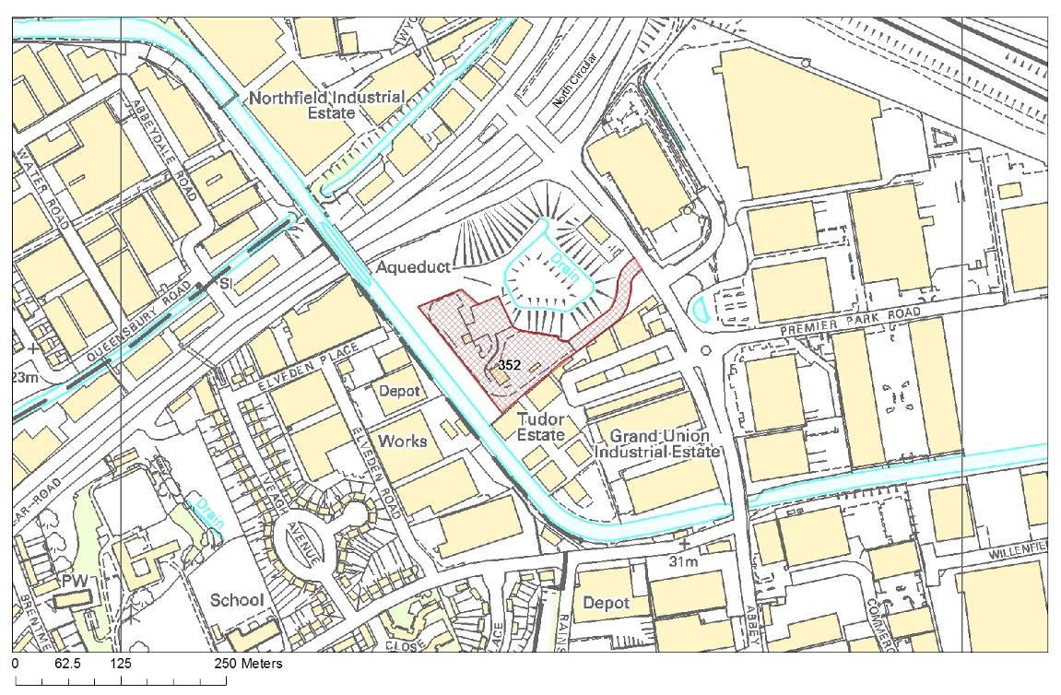

Site 1261 Veolia Transfer Station, Marsh Road, Alperton, Brent
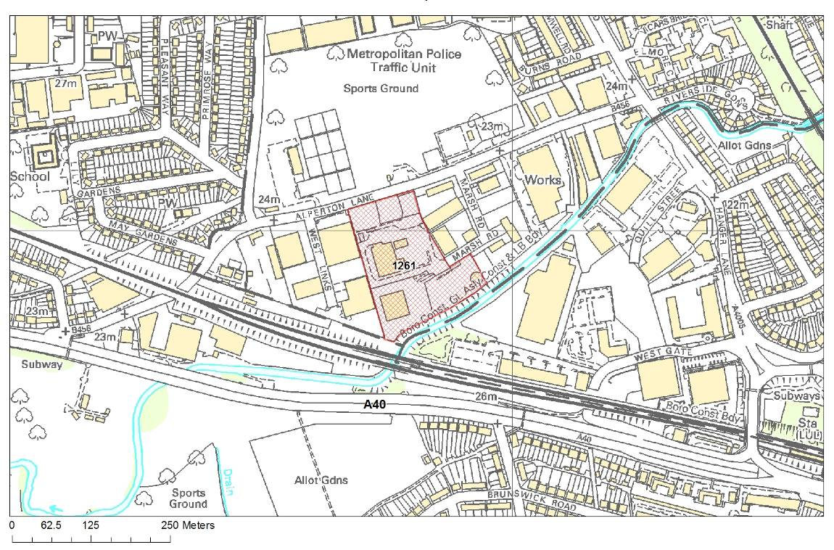

Site 309 Greenford Reuse & Recycling Site, Greenford Road, Greenford, Ealing
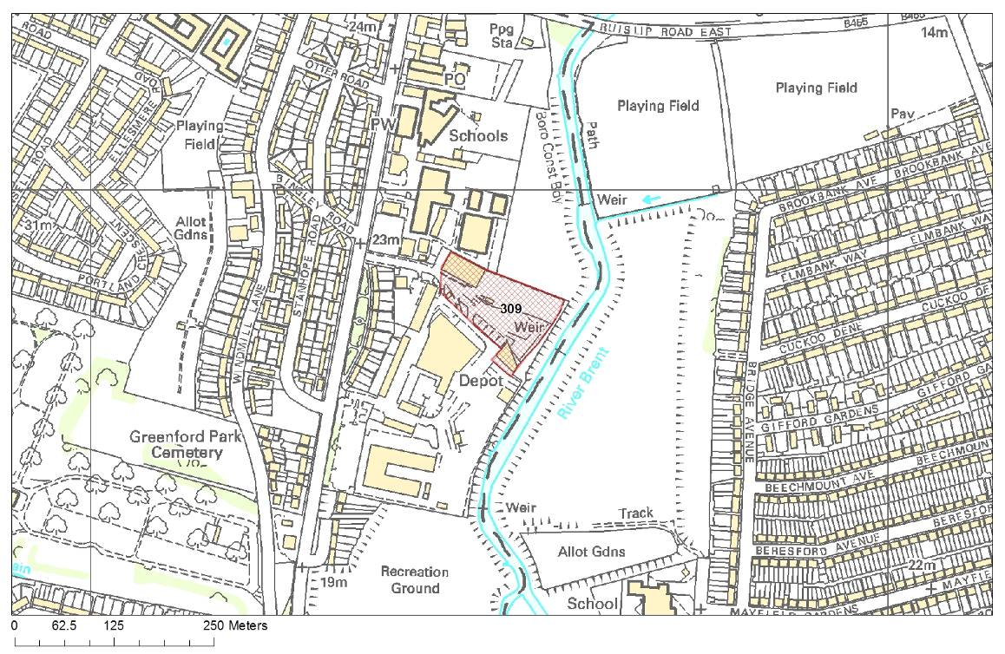

Site 310 Greenford Depot, Greenford Road, Greenford, Ealing
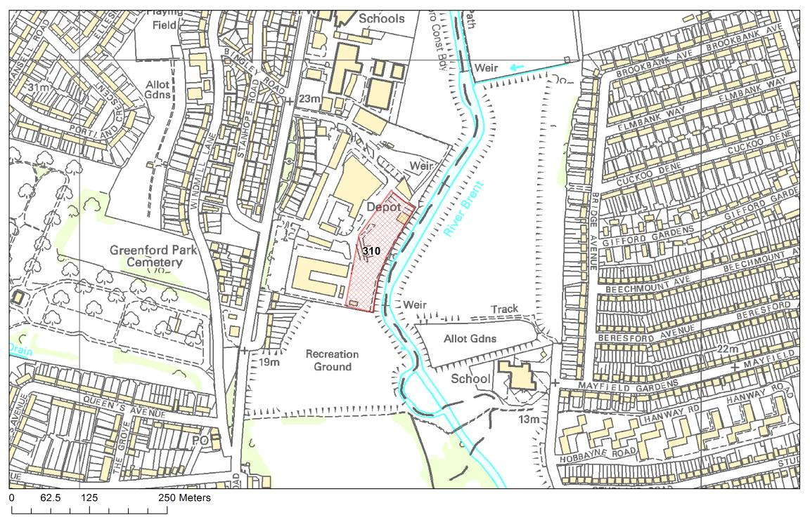

Site 328 Quattro, Victoria Road, Park Royal, Ealing
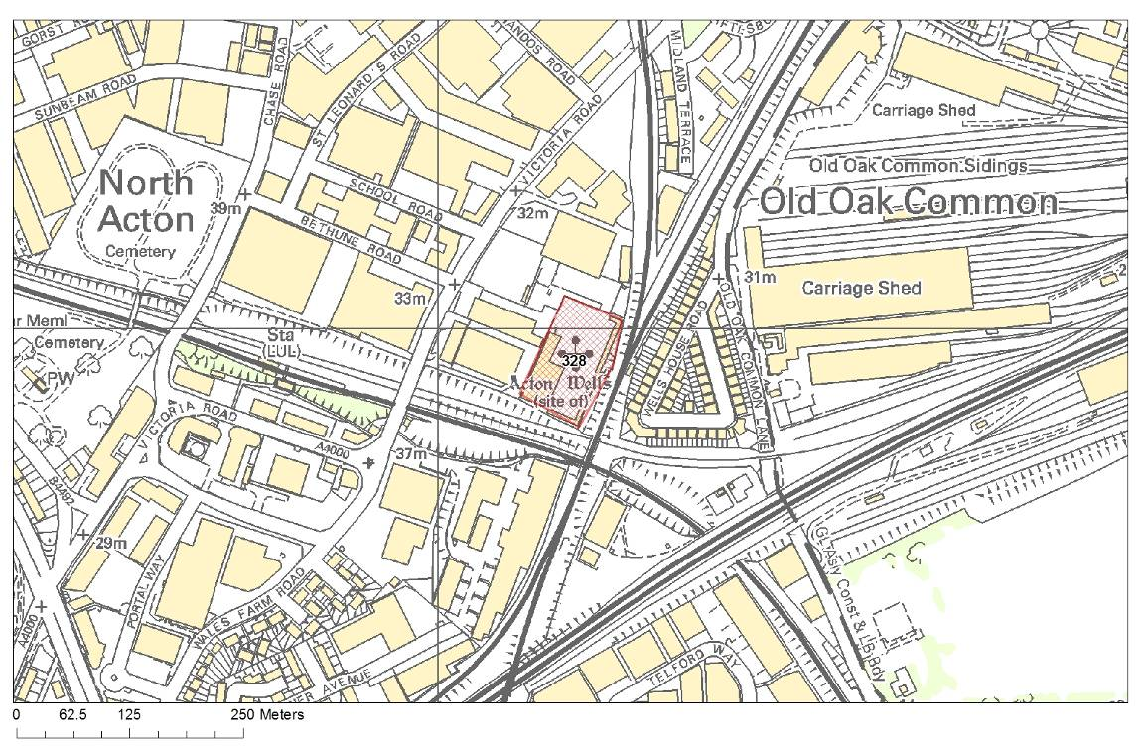

Site 303 Victoria Road Waste Transfer Station, Civic Way, Hillingdon
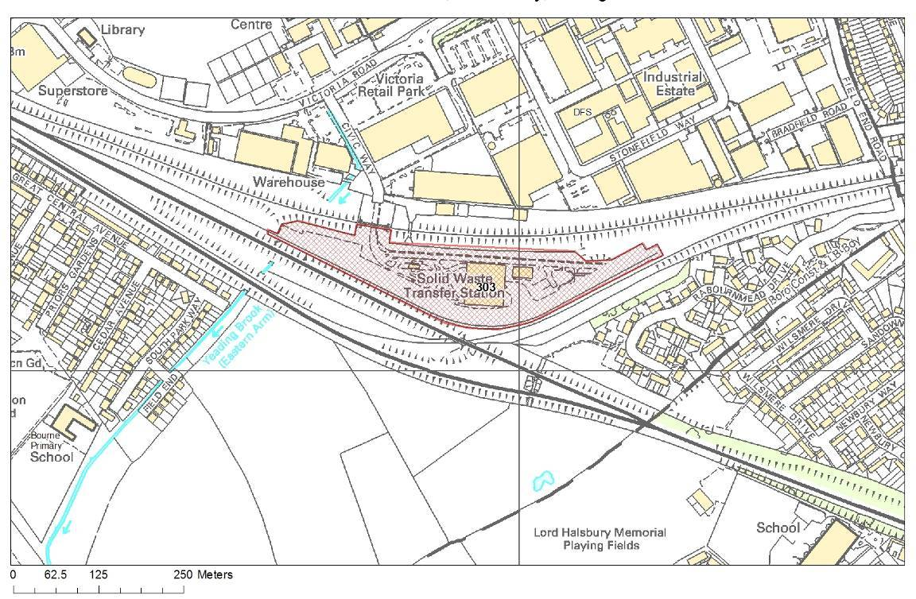

Site 353 Transfer Avenue Waste Transfer Station, Brentford, Hounslow
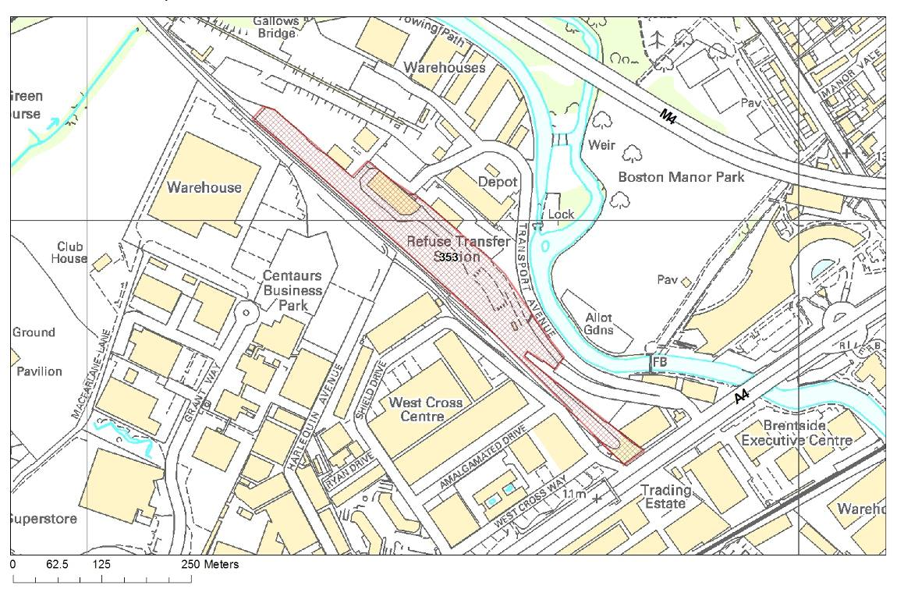

Site 342 Twickenham Depot, Langhorn Drive, Twickenham, Richmond
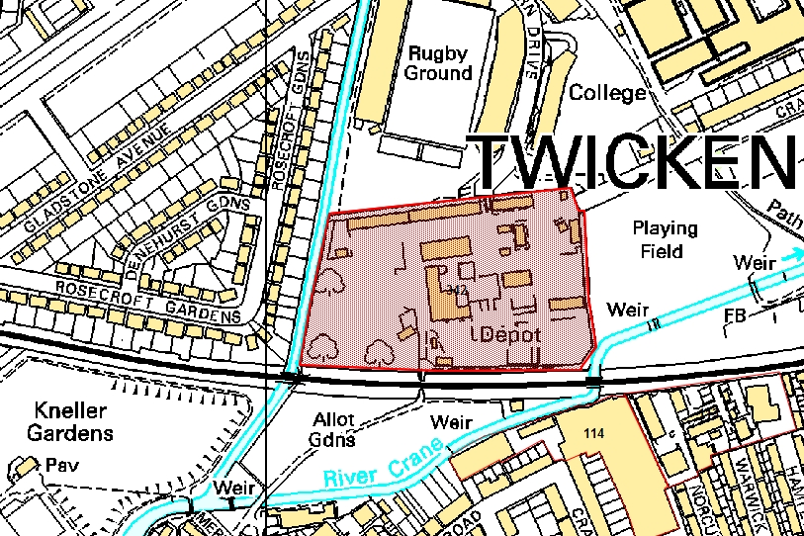

Appendix 5: Details of Proposed New Sites with opportunity for developing waste management facilities

Table 0-2: Proposed new sites with opportunity for developing waste management facilities
Site Number | Site Area (ha) | Borough | Description
222 | 1.83 | Harrow | Council depot, Forward Drive
244 | 3.12 | Hillingdon | Yeading Brook, Bulls Bridge
2861 | 3.20 | Hounslow | Western International Market

Site 222 Council Depot, Forward Drive, Harrow
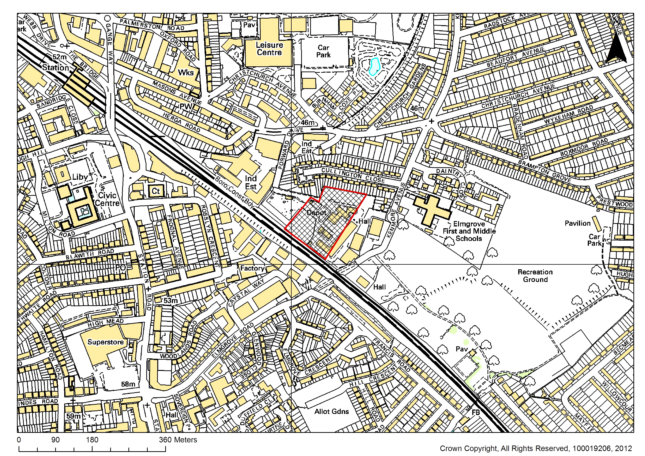

Site 244 Yeading Brook, Former Powergen Site, Bulls Bridge, Hayes, Hillingdon
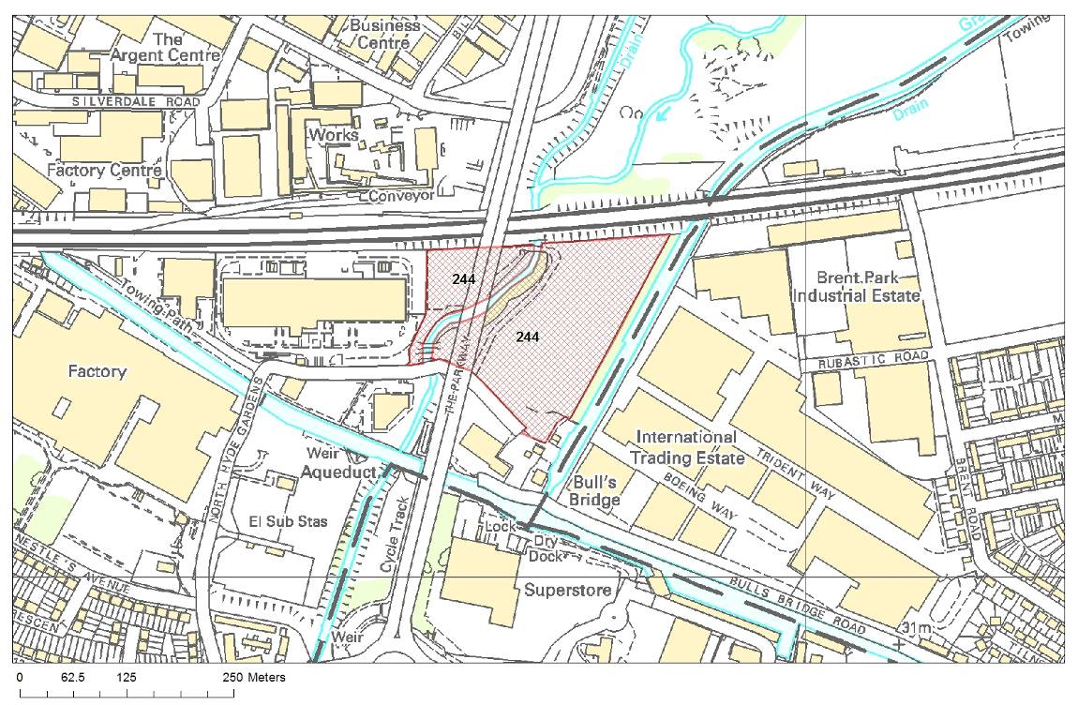

Site 2861 Vacant Site Western International Market, Hayes Road, Southall, Hounslow
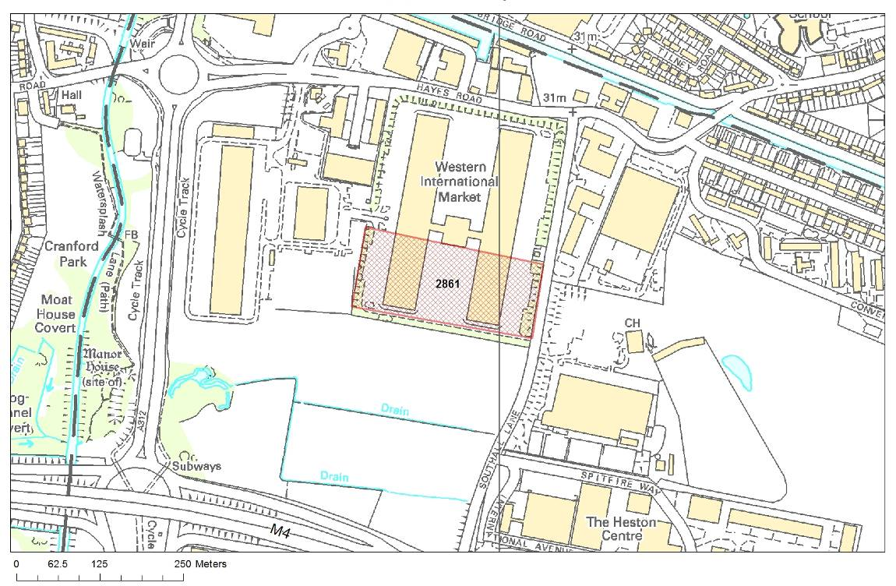

Waste Framework Directive (Directive 2008/98/EC - http://eur-lex.europa.eu/LexUriServ/LexUriServ.do?uri=CELEX:32008L0098:EN:NOT
The UK Government Sustainable Development Strategy - http://www.defra.gov.uk/publications/files/pb10589-securing-the-future-050307.pdf
Waste Strategy for England 2007 - http://archive.defra.gov.uk/environment/waste/strategy/strategy07/documents/waste07-strategy.pdf
Planning Policy Statement 10 - http://www.communities.gov.uk/documents/planningandbuilding/pdf/1876202.pdf
Defra Sustainable Development Unit - http://www.sustainable- development.gov.uk/publications/uk-strategy/framework-for-sd.htm
West London Waste Plan Issues and Options Report (February 2009) available to download from http://www.wlwp.net/documents.html
See: http://www.planningportal.gov.uk/uploads/pins/dpd_brief_guide_examining.pdf
The Waste Plan is a joint Core Strategy for waste. PPS12 outlines the requirements for Core Strategies in section 4: http://www.communities.gov.uk/publications/planningandbuilding/pps12lsp
WLWA Draft Joint Municipal Waste Management Strategy, September 2005 - http://www.westlondonwaste.gov.uk/west-london-waste-authority/strategy/
Waste Strategy for England (2007), Department for Environment, Food and Rural Affairs (DEFRA) www.defra.gov.uk
WLWA Procurement Strategy - http://www.westlondonwaste.gov.uk/west-london-waste-authority/procuremen/
European Waste Catalogue - http://www.environment-agency.gov.uk/static/documents/GEHO1105BJVS-e-e.pdf
WLWP Technical Report November 2011 - http://www.wlwp.net/documents.html
The full catalogue can be downloaded from http://www.environment-agency.gov.uk/static/documents/Leisure/EWC_31-03-09_CH.pdf
Defra Sustainable Development Unit - http://www.sustainable-development.gov.uk/publications/uk-strategy/framework-for-sd.htm.
European Directive 2001/42/EC “on the assessment of the effects of certain plans and programmes on the environment” (the Strategic Environmental Assessment or ‘SEA Directive’
The Environmental Assessment of Plans and Programmes Regulations. Statutory Instrument 2004 No. 1633.
Sustainability Appraisal Scoping Report for the WLWP July 2008.
West London Waste Plan Issues and Options, Sustainability Appraisal, Sustainability Commentary, February 2009.
Planning Policy Statement 25: Development and Flood Risk – DCLG, 2006.
European Directive 992/43/EC on the conservation of natural habitats and of wild fauna and flora and European Directive 79/409/EEC on the conservation of wild birds.

